UEI Number and SAM Registration
- Applicants for all grant funding opportunities from DCJS, MUST have a Unique Entity Identification (UEI) number for their entity.

- Entities applying for a grant including federal funds from DCJS, MUST have a UEI number AND an active System of Award Management (SAM) registration.

- DCJS requires applicants for grants including federal funds to have an active SAM registration at the time of grant submission. Applicants without an active registration will not be considered for funding; pending registrations and renewals are not acceptable.

NOTE: Applicants for all grant funding opportunities through DCJS, regardless of funding source, must have a UEI number and provide it as part of the grant application process. SAM registration is encouraged but not required for grants of state general funds or state special funds.


NOTE: If your entity does not have a UEI number or active SAM registration, be sure to get started well before the grant due date. It can take several days to validate an organization for UEI number and several weeks to obtain a full SAM registration.

What are they?
UEI
- A UEI number is a unique identifier issued by the federal government. This is used to help identify a business/organization.

- UEI numbers do not expire. Once assigned, the number remains valid indefinitely. Entities must update the information when changes to the legal business name or address occur.
SAM
- A SAM registration provides additional information that is used for grant or contractual purposes. SAM registration requires a UEI number.

- SAM registrations do expire and require annual renewals. Renewals should be completed before the expiration date.

Cost:
- Obtaining a UEI number and SAM registration are always FREE and only available through the federal government at sam.gov.

- Be aware: There are organizations that offer to help obtain a UEI number or SAM registration for a fee, but they are not associated with the federal government, nor is it required to use them. DCJS grant funds may not be used to pay a third party to set up a UEI or SAM registration.
Bonus benefit to having an active SAM registration: Entities that complete and maintain an active SAM registration will be positioned to apply for grants directly from the federal government. DCJS recommends all applicants take this step to be prepared for any funding opportunities that may come along.
How to Get, Update, or Verify a UEI Number

NOTE: You will need to establish an individual sam.gov account using login.gov. The sam.gov website will guide you to sign in or create an account if you do not already have one.

Getting started:
- Go to https://sam.gov.

- Scroll down to the box titled “How to get a Unique Entity ID” and watch the 10-minute video about the process of obtaining or updating a UEI number. This provides you with steps to obtain a UEI number and an overview of what you need to have handy, including what information you will need to enter (such as start year or year of incorporation) and documentation you may need to upload. This also covers how to update a UEI number and how to search for an existing UEI number.
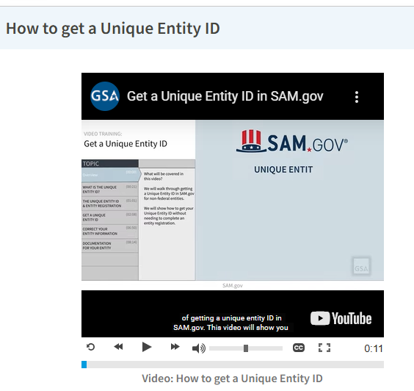
- When you are ready to request a UEI number for your entity, click on “Get Started” under the box titled “Register Your Entity or Get a Unique Entity ID”, which is on the landing page with the video. This will take you to a page titled “Get Started with Registration and the Unique Entity ID.”
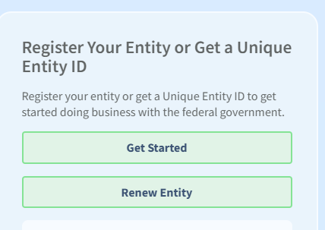
Sign in or set up a SAM.gov Account:
- Your first step will be to set up an individual SAM.gov Account.

- Choose either “sign in” in the top right-hand corner of the page to go directly to the login.gov page OR click on “Get Started” in the box like the one you just used. If you choose “Get Started” you will get a pop-up box like the one below.
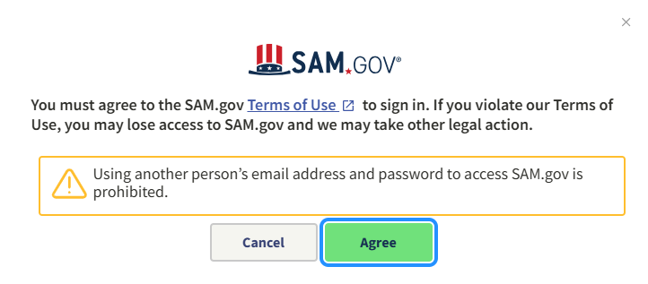
- Once you “agree” you will be taken to the login.gov page. “Sign in” will take you directly to the login.gov page.

- From the login.gov page, you can sign into an existing account, or you can create a new account.
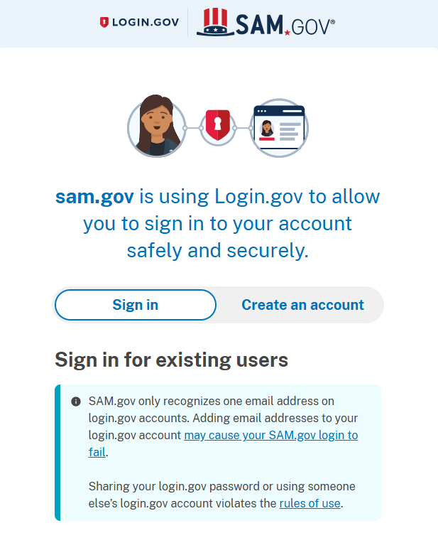
Request a UEI Number
- After you are signed in, proceed with entering the required data to obtain a UEI number and follow the steps as specified in the video.

- You will need to enter basic information and may need to provide documents to validate your entity as described in the video.

- Be sure to follow any instructions to finalize your entity’s UEI number.
Registering in SAM (required for all applicants requesting federal funds from DCJS)
- Before you register your entity in sam.gov, you must obtain a UEI number.

- When registering in SAM, you will need to determine what type of registration you want. There are two options:
- All Awards registration allows your entity to bid on federal contracts and other procurements, as well as apply for financial assistance.

- Financial Assistance Awards Only registration allows your entity to apply for financial assistance or grants and loans. This registration is generally enough for any entity that expects to only apply for federal grants or cooperative agreements.

- Once you have decided which is the best option for your organization, see the SAM Entity Registration Checklist to help you prepare for registration. The following link includes two checklists, one for each type of registration noted above: https://sam.gov/sites/default/files/2024-11/entity-checklist.pdf
Renewal:
- It is important that you renew your entity’s SAM registration before it expires.

- Renewal may require additional or updated information and could take several days to be accepted, so allow time to complete the process.
Be aware:
- There are many private companies that will send emails sounding as if you must renew your registration soon. These will start arriving months before your entity’s registration expires with “offers” to help. They can look official and will contain details about your registration. These entities will charge a fee to handle that process for you.

- A SAM registration, including renewal, is always FREE and does not necessitate a third party to do this on your behalf.

- The official notification for renewal will always come from an email with a “.gov” extension.

- If you choose to engage a third party for this purpose, note that grant funds from DCJS may not be used to pay the resulting fee.
Help
For help with obtaining a UEI number or SAM registration, choose the “Help” at the top of the page on the sam.gov website or go to https://sam.gov/help. This page includes links to self-help tools and live chat options.

