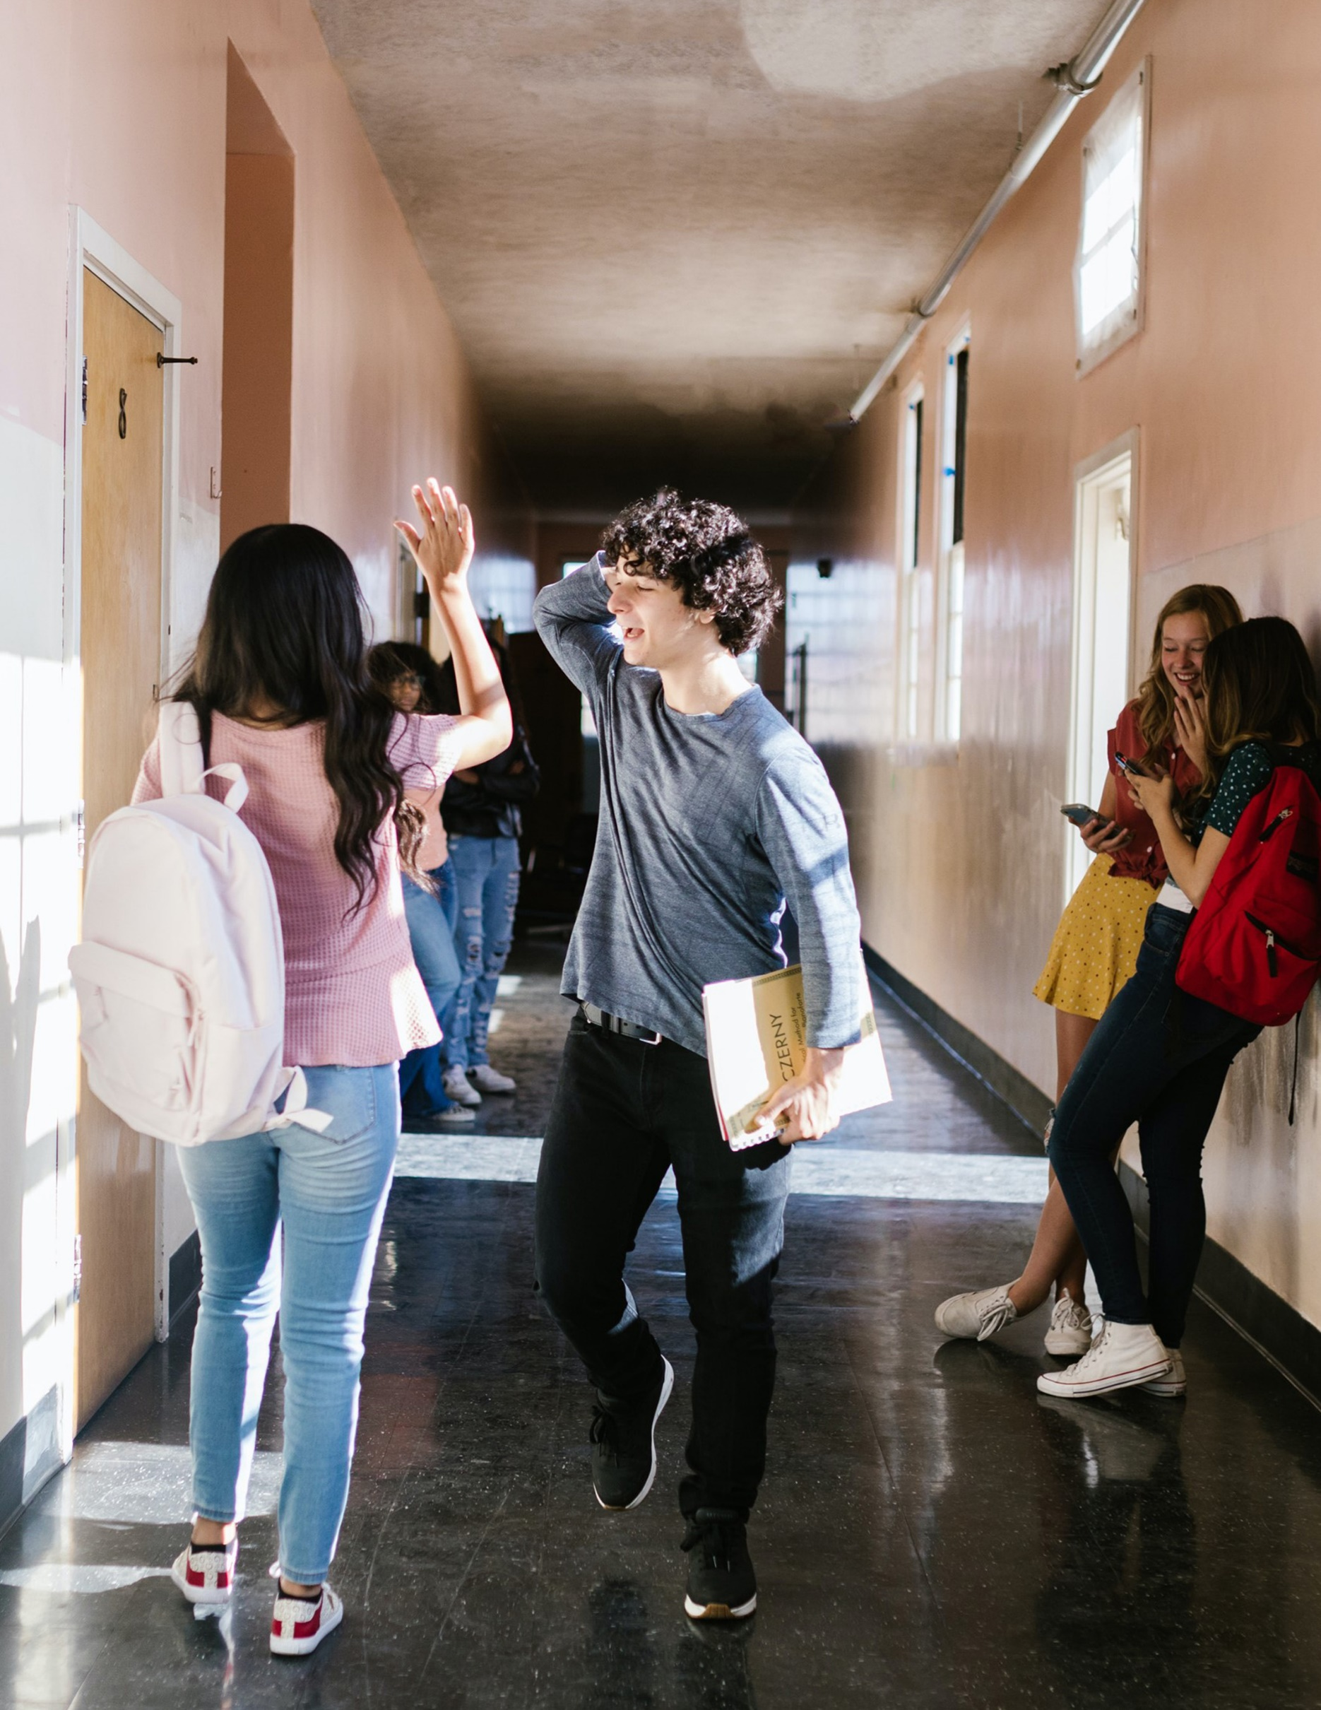

2025

School Crisis, Emergency Management, and Medical Emergency Response Plan Template – Resource Templates

School Crisis, Emergency Management, and Medical Emergency Response Plan Template – Resource Templates
Table of Contents
Before Section Resource Templates 1
Administrator’s Mobile Toolkit 2
Classroom Go-Kit Inventory 3
Clinic Go-Kit Inventory 4
Drill/Exercise After-Action Report 5
Sample Completed AAR 6
Drill/Exercise Log 7
Hazard Analysis 8
Individual Safety Plan 12
State Safety Audit Process 13
Sample Maps 14
School Safety Inspection 16
Shelter Kit Inventory 18
Staff Badge Access – Sample Timeframes 19
Staff Skills Survey 22
During Section Resource Templates 23
Bomb Threat Report Form 24
Incident Command System (ICS): School Assignments 25
Memorandum of Understanding (MOU) 26
Standard Response Protocol Public Address Announcements 29
After Section Resource Templates 30
Essential Departments and Functions for Division Level 31
Standard Reunification Method (SRM) Information Card 35

Resource Templates
The resource templates in this section are designed to provide sample charts, forms, and checklists to assist in carrying out tasks discussed in the School Crisis, Emergency Management, and Medical Emergency Response Plan (CMP). These are samples only and should be modified or adapted to fit the needs of the specific school or division.

Before Section Resource Templates
The documents listed below relate to tasks discussed in the Before section of the CMP Template. These actions support the prevention/mitigation, protection, and preparedness phases of emergency management.

Document Title | Type of Document
Administrator’s Mobile Toolkit | Checklist
Classroom Go-Kit Inventory | Checklist
Clinic Go-Kit Inventory | Checklist
Drill/Exercise After-Action Report | Template, Completed sample
Drill/Exercise Log | Template
Hazard Analysis | Template
Individual Safety Plan | Informational, Link to templates
Overview of State Safety Audit Process | Informational
Sample Maps | Completed sample
School Safety Inspection | Informational, Link to checklist
Shelter Kit Inventory | Checklist
Staff Badge Access | Completed Sample
Staff Skills Survey | Informational, Link to templates

The following documents produced by the Virginia Department of Criminal Justice Services (DCJS) should be reviewed for additional considerations when completing the CMP template.
- Division Guide for Crisis Management Planning
- The Virginia Educator’s Guide for Planning and Conducting School Emergency Drills
- Threat Assessment and Management in Virginia Public Schools: Model Policies, Procedures, and Guidelines
- Virginia Safety Planning Guide for Individuals with Special Needs

Administrator’s Mobile Toolkit
This toolkit should be kept in a brightly colored portable container and stored in a secure area. An administrator should be assigned to take the kit during any emergency activation.

- Printed copy of CMP
- School neighborhood map
- School campus aerial photos
- School floor plans
- School map of all staging areas
- School utilities system diagram (gas and utility lines)
- Evacuation route
- On-site gathering location
- Staff roster with special skills listed
- Map of emergency response equipment
- Inventory list for First aid and bleeding control stations
- Contact information for:
  - Division-level administrators
  - Responding agencies
  - Utility providers
- Keys (should be in a locked container in the kit or in the Knox Box – rapid entry system)
- Master key
- Keys for rooms the Master does not open
- Property gate keys
- Procedures for turning off the fire alarm system
- Procedures for shutting off the sprinkler system
- Procedures for disarming alarm systems
- Staff and student photos (most current available)
- Master roster of all classes
- Master bus schedules
- Bell schedule
- Blank notepads
- Pens, pencils, other writing devices
- Blank copy of ICS Incident log
- First aid kit with latex-free surgical gloves
- Flashlight (batteries should be refreshed every 6 months)

When exiting the building or moving locations:
- Student attendance roster for the day
- Visitor and substitute teacher log for the day
- Extra two-way radios

Classroom Go-Kit Inventory
Classroom go-kits should be stored near the classroom door in a highly visible, easily portable bag. Go-kits should be taken with the class during an emergency that requires relocating from the classroom.

Folder containing:
- Emergency phone numbers
- Buddy Teacher list
- Evacuation route map
- Assembly areas
- Instructions for substitute teacher
- General response protocol overview
- Hazard-specific responses
- Class rosters (update monthly)
- List of assigned students with access or functional needs
- Blank paper
- Brightly colored vest to be worn by the teacher
- Blank copies of student release forms
- Red/Green status cards

Additional kit items:
- Basic first aid kit
- Pressure dressings
- Latex-free gloves
- Flashlight (batteries should be refreshed every 6 months)
- Large garbage bags (1 per student to keep warm or dry)
- Whistle
- Small garbage bags with ties for sanitation
- Tissues (1 box or roll)
- Hand sanitizer/wet wipes
- Scissors
- Small snacks (allergen-free) – optional
- Small games/activities – optional

Clinic Go-Kit Inventory
The clinic go-kit should be kept in a secure location and stored in an easily portable container marked as “MEDICAL” or utilizing the ISO 7010 symbol of a green cross on a white background or a white cross on a green background. The school nurse should monitor and resupply the kit as needed.

- Disposable bottled water
- Flashlight (batteries should be refreshed every 6 months)
- Radio (battery operated)
- Duct tape
- Large plastic trash bags
- Assorted bandages and sterile pads
- Oval eye patches
- Matches
- Pillow
- Tongue depressors
- Sterile water (for burns)
- Instant ice packs
- Hypo-allergenic tape
- Scissors
- Tweezers
- Gauze rolls
- Ace bandages
- Sewing needle and thread
- Safety pins (various sizes)
- Waterless antibacterial soap
- Steri-Strips (butterfly closures)
- Latex-free disposable gloves
- Eye protection masks
- Sugar source for diabetic students/staff
- Sanitary napkins
- Finger splints
- Cardboard splints
- Folder with needed paperwork:
- Student medication disbursement list
- Individuals with ISPs
- Blank paper
- Map of mobility aids
- Map of first aid kits
- Map of bleeding control kits
- Inventory of first aid kits
- Inventory of bleeding control kits

When exiting the building or moving locations:
- Student medications (prioritized by medical need and availability)
- Mobile AED

Drill/Exercise After-Action Report
An after-action report (AAR) should be completed after each drill or exercise is debriefed by the School Safety Team.

Drill/Exercise Information
Drill/Exercise: | Drill/Exercise Date: | Threat or Hazard: | Scenario:

Drill/Exercise Analysis
Objective: | Performed without Challenges (P) | Performed with Some Challenges (S) | Performed with Major Challenges (M) | Unable to Be Performed (U)
(Add additional objectives as needed)

Objective and Challenge Faced: | Corrective Action: | Person Responsible: | Date Completed:

Sample Completed AAR

Drill/Exercise Information
Drill/Exercise: | Drill/Exercise Date: | Threat or Hazard: | Scenario:
October Fire Drill | October 15, 2024 | Fire | Fire erupted in the kitchen while 7th grade students were exiting the cafeteria between lunch periods

Drill/Exercise Analysis
Objective: | Performed without Challenges (P) | Performed with Some Challenges (S) | Performed with Major Challenges (M) | Unable to Be Performed (U)
Practice evacuation routes during non-classroom times | P
Practice teacher/student recall of secondary evacuation routes |  | S
Practice student recall of gathering locations during an evacuation |  |  | M
Ensure all students, staff, and visitors leave the building in an orderly and timely fashion | P
Practice student, staff, and visitor accountability process |  | S

Objective and Challenge Faced: | Corrective Action: | Person Responsible: | Date to be Completed:
Practice teacher/student recall of secondary evacuation routes. Challenge: Secondary routes were not utilized efficiently. | Review secondary evacuation routes with teachers assigned to classrooms nearest to the cafeteria | Mrs. Jones, Team Lead | November 1, 2024
Practice student recall of gathering locations during an evacuation. Challenge: 7th grade students did not move to the assigned location after exiting the building. | Review gathering locations with 7th grade students; walk to meeting location | 4th period teachers  (7th grade only) | November 1, 2024
Practice student, staff, and visitor accountability process. Challenge: Time to account for students who were not with their assigned class exceeded acceptable time. | Review documentation and communication process with teachers when students are not assigned to their class | Mr. Smith, AP | November 1, 2024

Drill/Exercise Log
A drill/exercise log should be completed after the AAR has occurred with the school safety team, no later than five school days after the drill/exercise was conducted. Logs should be stored either digitally or on paper in an easy-to-review manner and produced when requested by division-level staff or fire marshal officials.

School Name: |  |  |  |  |  |  |  |  |  |  | Drill Conducted:
Date of Drill: |  |  |  |  |  |  |  |  |  |  | Drill Led By:
Date AAR Completed: |  |  |  |  |  |  |  |  |  |  | Date Log Completed:
Members of the School Safety Team Present for AAR:
# of Students Participating: |  |  |  |  |  |  |  |  |  |  | # of Staff Participating:
Were visitors present at the time of the drill/exercise? |  |  |  |  | ☐ Yes |  | ☐ No |  |  |  |  | Did visitors follow all directions given? |  |  | ☐ Yes | ☐ No
Scenario tested during drill/exercise:
Special circumstances simulated:
Were first responders present for observation? |  |  | ☐ Yes |  |  | ☐ No |  |  |  | Was feedback given by  first responders? |  |  |  |  | ☐ Yes | ☐ No
Was feedback solicited  from staff members? |  |  | ☐ Yes |  |  | ☐ No |  |  |  | Were drill/exercise actions reviewed with students? |  |  |  |  | ☐ Yes | ☐ No
Feedback provided by responders, staff, or students:

Hazard Analysis
In addition to using the data sources listed in the CMP Template Before Section, planning teams should develop a master list of all threats and hazards, assess the likelihood of occurrence, and plan a site-specific mitigation strategy. School safety teams should err on the side of caution in evaluating risks and identifying vulnerabilities so that plans are developed for the worst possible outcome and can be scaled back as needed.
Hazard | Probability | Magnitude | Warning | Duration | Risk Priority
Extreme Heat/  Drought | 4. Highly Likely  3. Likely  2. Possible  1. Unlikely | 4. Catastrophic  3. Critical  2. Limited  1. Negligible | 4. Minimal  3. 6–12 hrs  2. 12–24 hrs  1. 24+ hrs | 4.12+ hrs  3. 6–12 hrs  2. 3–6 hrs  1. <3 hrs | High  Medium  Low
Flooding/  Flash Flooding | 4. Highly Likely  3. Likely  2. Possible  1. Unlikely | 4. Catastrophic  3. Critical  2. Limited  1. Negligible | 4. Minimal  3. 6–12 hrs  2. 12–24 hrs  1. 24+ hrs | 4.12+ hrs  3. 6–12 hrs  2. 3–6 hrs  1. <3 hrs | High  Medium  Low
Hail | 4. Highly Likely  3. Likely  2. Possible  1. Unlikely | 4. Catastrophic  3. Critical  2. Limited  1. Negligible | 4. Minimal  3. 6–12 hrs  2. 12–24 hrs  1. 24+ hrs | 4.12+ hrs  3. 6–12 hrs  2. 3–6 hrs  1. <3 hrs | High  Medium  Low
Hurricane/  Reception Support | 4. Highly Likely  3. Likely  2. Possible  1. Unlikely | 4. Catastrophic  3. Critical  2. Limited  1. Negligible | 4. Minimal  3. 6–12 hrs  2. 12–24 hrs  1. 24+ hrs | 4.12+ hrs  3. 6–12 hrs  2. 3–6 hrs  1. <3 hrs | High  Medium  Low
Infestation/Disease | 4. Highly Likely  3. Likely  2. Possible  1. Unlikely | 4. Catastrophic  3. Critical  2. Limited  1. Negligible | 4. Minimal  3. 6–12 hrs  2. 12–24 hrs  1. 24+ hrs | 4.12+ hrs  3. 6–12 hrs  2. 3–6 hrs  1. <3 hrs | High  Medium  Low
Mold/Air Quality | 4. Highly Likely  3. Likely  2. Possible  1. Unlikely | 4. Catastrophic  3. Critical  2. Limited  1. Negligible | 4. Minimal  3. 6–12 hrs  2. 12–24 hrs  1. 24+ hrs | 4.12+ hrs  3. 6–12 hrs  2. 3–6 hrs  1. <3 hrs | High  Medium  Low
Thunderstorm/  Lightning | 4. Highly Likely  3. Likely  2. Possible  1. Unlikely | 4. Catastrophic  3. Critical  2. Limited  1. Negligible | 4. Minimal  3. 6–12 hrs  2. 12–24 hrs  1. 24+ hrs | 4.12+ hrs  3. 6–12 hrs  2. 3–6 hrs  1. <3 hrs | High  Medium  Low
Tornado/  Straight-Line Winds | 4. Highly Likely  3. Likely  2. Possible  1. Unlikely | 4. Catastrophic  3. Critical  2. Limited  1. Negligible | 4. Minimal  3. 6–12 hrs  2. 12–24 hrs  1. 24+ hrs | 4.12+ hrs  3. 6–12 hrs  2. 3–6 hrs  1. <3 hrs | High  Medium  Low
Tremors/  Earthquake | 4. Highly Likely  3. Likely  2. Possible  1. Unlikely | 4. Catastrophic  3. Critical  2. Limited  1. Negligible | 4. Minimal  3. 6–12 hrs  2. 12–24 hrs  1. 24+ hrs | 4.12+ hrs  3. 6–12 hrs  2. 3–6 hrs  1. <3 hrs | High  Medium  Low
Urban Wildland Interface/Fire | 4. Highly Likely  3. Likely  2. Possible  1. Unlikely | 4. Catastrophic  3. Critical  2. Limited  1. Negligible | 4. Minimal  3. 6–12 hrs  2. 12–24 hrs  1. 24+ hrs | 4.12+ hrs  3. 6–12 hrs  2. 3–6 hrs  1. <3 hrs | High  Medium  Low
Winter Storm | 4. Highly Likely  3. Likely  2. Possible  1. Unlikely | 4. Catastrophic  3. Critical  2. Limited  1. Negligible | 4. Minimal  3. 6–12 hrs  2. 12–24 hrs  1. 24+ hrs | 4.12+ hrs  3. 6–12 hrs  2. 3–6 hrs  1. <3 hrs | High  Medium  Low
Building Collapse | 4. Highly Likely  3. Likely  2. Possible  1. Unlikely | 4. Catastrophic  3. Critical  2. Limited  1. Negligible | 4. Minimal  3. 6–12 hrs  2. 12–24 hrs  1. 24+ hrs | 4.12+ hrs  3. 6–12 hrs  2. 3–6 hrs  1. <3 hrs | High  Medium  Low
Energy/Fuel Shortage | 4. Highly Likely  3. Likely  2. Possible  1. Unlikely | 4. Catastrophic  3. Critical  2. Limited  1. Negligible | 4. Minimal  3. 6–12 hrs  2. 12–24 hrs  1. 24+ hrs | 4.12+ hrs  3. 6–12 hrs  2. 3–6 hrs  1. <3 hrs | High  Medium  Low
Hazardous Materials | 4. Highly Likely  3. Likely  2. Possible  1. Unlikely | 4. Catastrophic  3. Critical  2. Limited  1. Negligible | 4. Minimal  3. 6–12 hrs  2. 12–24 hrs  1. 24+ hrs | 4.12+ hrs  3. 6–12 hrs  2. 3–6 hrs  1. <3 hrs | High  Medium  Low
Major Urban Structure Fire | 4. Highly Likely  3. Likely  2. Possible  1. Unlikely | 4. Catastrophic  3. Critical  2. Limited  1. Negligible | 4. Minimal  3. 6–12 hrs  2. 12–24 hrs  1. 24+ hrs | 4.12+ hrs  3. 6–12 hrs  2. 3–6 hrs  1. <3 hrs | High  Medium  Low
Plane Crash | 4. Highly Likely  3. Likely  2. Possible  1. Unlikely | 4. Catastrophic  3. Critical  2. Limited  1. Negligible | 4. Minimal  3. 6–12 hrs  2. 12–24 hrs  1. 24+ hrs | 4.12+ hrs  3. 6–12 hrs  2. 3–6 hrs  1. <3 hrs | High  Medium  Low
Pipeline Failure | 4. Highly Likely  3. Likely  2. Possible  1. Unlikely | 4. Catastrophic  3. Critical  2. Limited  1. Negligible | 4. Minimal  3. 6–12 hrs  2. 12–24 hrs  1. 24+ hrs | 4.12+ hrs  3. 6–12 hrs  2. 3–6 hrs  1. <3 hrs | High  Medium  Low
Telecommunication Failure | 4. Highly Likely  3. Likely  2. Possible  1. Unlikely | 4. Catastrophic  3. Critical  2. Limited  1. Negligible | 4. Minimal  3. 6–12 hrs  2. 12–24 hrs  1. 24+ hrs | 4.12+ hrs  3. 6–12 hrs  2. 3–6 hrs  1. <3 hrs | High  Medium  Low
Bus/Vehicle Wreck | 4. Highly Likely  3. Likely  2. Possible  1. Unlikely | 4. Catastrophic  3. Critical  2. Limited  1. Negligible | 4. Minimal  3. 6–12 hrs  2. 12–24 hrs  1. 24+ hrs | 4.12+ hrs  3. 6–12 hrs  2. 3–6 hrs  1. <3 hrs | High  Medium  Low
Water/Wastewater System Failure | 4. Highly Likely  3. Likely  2. Possible  1. Unlikely | 4. Catastrophic  3. Critical  2. Limited  1. Negligible | 4. Minimal  3. 6–12 hrs  2. 12–24 hrs  1. 24+ hrs | 4.12+ hrs  3. 6–12 hrs  2. 3–6 hrs  1. <3 hrs | High  Medium  Low
Train Derailment | 4. Highly Likely  3. Likely  2. Possible  1. Unlikely | 4. Catastrophic  3. Critical  2. Limited  1. Negligible | 4. Minimal  3. 6–12 hrs  2. 12–24 hrs  1. 24+ hrs | 4.12+ hrs  3. 6–12 hrs  2. 3–6 hrs  1. <3 hrs | High  Medium  Low
Bomb/Terrorist Threat | 4. Highly Likely  3. Likely  2. Possible  1. Unlikely | 4. Catastrophic  3. Critical  2. Limited  1. Negligible | 4. Minimal  3. 6–12 hrs  2. 12–24 hrs  1. 24+ hrs | 4.12+ hrs  3. 6–12 hrs  2. 3–6 hrs  1. <3 hrs | High  Medium  Low
Civil Disorder | 4. Highly Likely  3. Likely  2. Possible  1. Unlikely | 4. Catastrophic  3. Critical  2. Limited  1. Negligible | 4. Minimal  3. 6–12 hrs  2. 12–24 hrs  1. 24+ hrs | 4.12+ hrs  3. 6–12 hrs  2. 3–6 hrs  1. <3 hrs | High  Medium  Low
Felony Crimes | 4. Highly Likely  3. Likely  2. Possible  1. Unlikely | 4. Catastrophic  3. Critical  2. Limited  1. Negligible | 4. Minimal  3. 6–12 hrs  2. 12–24 hrs  1. 24+ hrs | 4.12+ hrs  3. 6–12 hrs  2. 3–6 hrs  1. <3 hrs | High  Medium  Low
Hostage | 4. Highly Likely  3. Likely  2. Possible  1. Unlikely | 4. Catastrophic  3. Critical  2. Limited  1. Negligible | 4. Minimal  3. 6–12 hrs  2. 12–24 hrs  1. 24+ hrs | 4.12+ hrs  3. 6–12 hrs  2. 3–6 hrs  1. <3 hrs | High  Medium  Low
Mass Casualty | 4. Highly Likely  3. Likely  2. Possible  1. Unlikely | 4. Catastrophic  3. Critical  2. Limited  1. Negligible | 4. Minimal  3. 6–12 hrs  2. 12–24 hrs  1. 24+ hrs | 4.12+ hrs  3. 6–12 hrs  2. 3–6 hrs  1. <3 hrs | High  Medium  Low
Campus Death(s) | 4. Highly Likely  3. Likely  2. Possible  1. Unlikely | 4. Catastrophic  3. Critical  2. Limited  1. Negligible | 4. Minimal  3. 6–12 hrs  2. 12–24 hrs  1. 24+ hrs | 4.12+ hrs  3. 6–12 hrs  2. 3–6 hrs  1. <3 hrs | High  Medium  Low
Security Breach/  Trespassing | 4. Highly Likely  3. Likely  2. Possible  1. Unlikely | 4. Catastrophic  3. Critical  2. Limited  1. Negligible | 4. Minimal  3. 6–12 hrs  2. 12–24 hrs  1. 24+ hrs | 4.12+ hrs  3. 6–12 hrs  2. 3–6 hrs  1. <3 hrs | High  Medium  Low
Terrorism/  Bio Terrorism | 4. Highly Likely  3. Likely  2. Possible  1. Unlikely | 4. Catastrophic  3. Critical  2. Limited  1. Negligible | 4. Minimal  3. 6–12 hrs  2. 12–24 hrs  1. 24+ hrs | 4.12+ hrs  3. 6–12 hrs  2. 3–6 hrs  1. <3 hrs | High  Medium  Low
Weapons Incidents | 4. Highly Likely  3. Likely  2. Possible  1. Unlikely | 4. Catastrophic  3. Critical  2. Limited  1. Negligible | 4. Minimal  3. 6–12 hrs  2. 12–24 hrs  1. 24+ hrs | 4.12+ hrs  3. 6–12 hrs  2. 3–6 hrs  1. <3 hrs | High  Medium  Low
Cyber Security Breach | 4. Highly Likely  3. Likely  2. Possible  1. Unlikely | 4. Catastrophic  3. Critical  2. Limited  1. Negligible | 4. Minimal  3. 6–12 hrs  2. 12–24 hrs  1. 24+ hrs | 4.12+ hrs  3. 6–12 hrs  2. 3–6 hrs  1. <3 hrs | High  Medium  Low

Individual Safety Plan
The TEAMS Framework can be used to streamline identification and preparation for the access and functional needs of students, staff, and visitors such as volunteers, parents, delivery personnel, substitutes, and guests. While it is often not possible to know the needs of some individuals ahead of time, the TEAMS Framework can help prepare with inclusivity in mind.
Support Category | Definition | Examples of Need
T  Transportation and Mobility | Accommodations necessary to support an individual’s movement to safety, alternative location, or protective position during and after a crisis | Individuals in wheelchairs (manual and electric), with crutches, requiring lift and/or stair equipment, medically fragile individuals, pregnant individuals, etc.
E  Emotional, Mental and Behavioral Health | Accommodations, personnel, procedures, services, or specialized preparation required to ensure an individual’s emotional well-being and/or behavioral health during a crisis | Individuals with ADHD, sensory disorders, anxiety, trauma history, PTSD, cognitive or intellectual impairment, etc.
A  Auxiliary Communication | Accommodations, personnel, equipment, or specialized training required to assist an individual’s ability to receive, understand, and relay information during a crisis | Individuals with speech or cognitive disabilities and impairments, visual impairments/blindness, deaf or hard of hearing, etc., as well as English Language Learners and individuals who speak a language other than English
M  Medical | Medicine, medical care, specialized training, equipment, or medical protocols required to ensure an individual’s safety during a crisis | Individuals with medical conditions such as asthma, allergies, diabetes, medical fragility, seizure disorders, traumatic brain injury, physical injury, impairment, etc.
S  Security and Supervision | Additional equipment, training, protocols, and personnel required to maintain accountability and security of an individual during and after a crisis | Individuals for whom traditional lockdown presents a physical, sensory, or emotional challenge, those who cannot remain quiet or stationary, individuals who are known to elope (run away) or initiate self-evacuation in a crisis, etc.

For planning purposes, the Virginia Safety Planning Guide for Individuals with Special Needs provides templates related to:
- Compiling a list of all individuals who may require an ISP (page 24)
- Completing an ISP per individual (page 25)
- Completing a TEAMS worksheet to identify and arrange necessary supports (page 26)

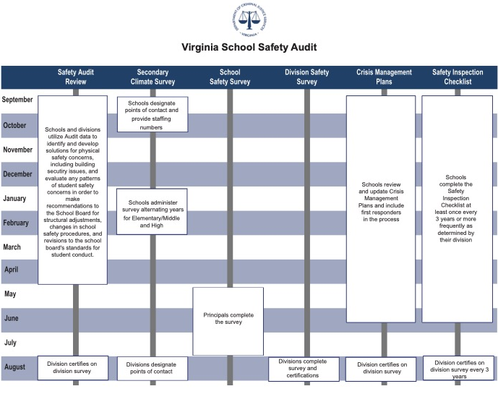
State Safety Audit Process

Virginia School Safety Audit (Accessible Content)

Safety Audit Review
September – April: Schools and divisions utilize Audit data to identify and develop solutions for physical safety concerns, including building security issues, and evaluate any patterns of student safety concerns in order to make recommendations to the School Board for structural adjustments, changes in school safety procedures, and revisions to the school board’s standards for student conduct
August: Division certifies on the division survey

Secondary Climate Survey
September – October: Schools designate points of contact and provide staffing numbers
January – February: Schools administer the survey alternating years for Elementary/Middle and High
August: Divisions designate points of contact

School Safety Survey
May – July: Principals complete the survey

Division Safety Survey
August: Divisions complete survey and certifications

Crisis Management Plans
September – June: Schools review and update Crisis Management Plans and include first responders in the process
August: Division certifies on division survey

Safety Inspection Checklist
September – June: Schools complete the Safety Inspection Checklist at least once every 3 years or more frequently as determined by their divisions
August: Division certifies on the division survey every 3 years

Sample Maps
Maps should be clearly marked and consistently labeled across schools within the same division. The following maps will need to be developed to complete the CMP Template. Additional maps may be created for site-specific needs and should be added to the applicable response section. Some maps may be combined (e.g., evacuation routes with building entry points or mobility aids with medical supplies), so long as all requirements for each map are included and the map does not become too cluttered.

Maps Needed for CMP Template:
- Building Entry Points: Labeled with assigned door number
- Emergency Alert (if installed): Activation buttons, notification lights
- Fire Safety: Pull stations, sensor zones, fire extinguishers, fire panel
- Medical Supplies: Bleeding control kits, first aid kits, AED
- Mobility Aids: Wheelchair, backboard, carrying device, evacuation chair
- Primary and Secondary Evacuation Routes (Red for primary, Blue for secondary)
- Reunification Staging
- Shelter Areas: Weather and HazMat
- Site Map: Boundaries and entry points, all buildings, utility lines, and shut-off points

Sample Interior Mapping
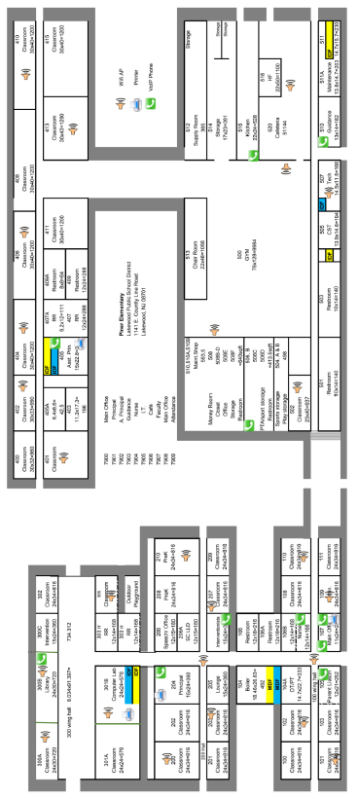

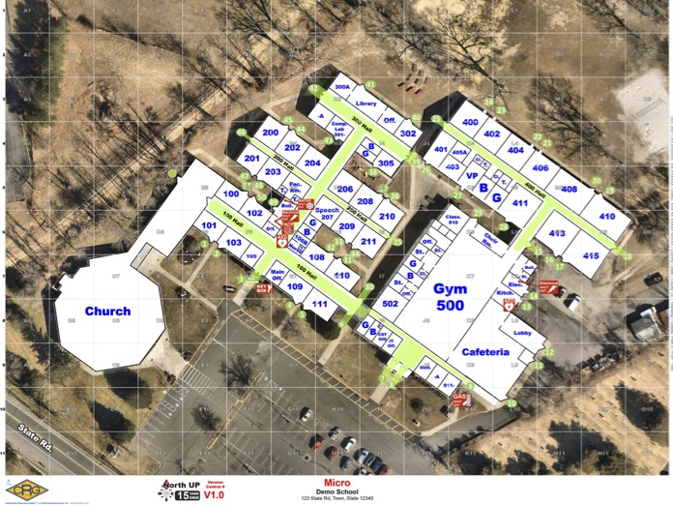
Sample Exterior Mapping

School Safety Inspection
Regular assessments of the school’s safety features should be conducted to ensure they are functioning as intended. For a detailed checklist and expected standards, download the School Safety Inspection Checklist for Virginia Public Schools. The checklist covers the following items:

Exterior:
- Fencing and gates
- Lighting
- Building, grounds, and landscape maintenance
- Surveillance cameras and alarm systems
- Signage and property entrance
- Building entry points: Doors and windows
- Key control
- Walkways, covers, ledges, and roof access
- Modular, portable, and auxiliary buildings
- Traffic and parking lot design and use
- Vehicle loading areas

Interior:
- Exit signs and emergency lighting
- Interior lighting
- Identification badges (students, staff, and visitors)
- Digital records security
- Property inventory
- Two-way communication
- Entryway and hallways
- Cafeteria, gyms, auditorium, restrooms, and other common areas
- Classrooms, including high-risk classrooms such as music rooms and computer labs
- Storage closets and mechanical rooms

Shelter Kit Inventory
In addition to the classroom go-kit, each shelter location should have a shelter kit stocked with enough supplies for the expected number of individuals assigned to that shelter.
- 5-gallon bucket (to store supplies and use as a toilet if needed)
- Toilet supplies
- Small plastic bags with ties
- Toilet paper
- Hand-washing supplies, wet wipes, or hand sanitizer
- Duct tape (2 rolls)
- Plastic sheeting to cover doors and windows
- Drinking water and cups
- Space blankets
- Tarp or ground cover
- Portable radio and batteries (batteries should be refreshed every 6 months)
- Flashlight and batteries (batteries should be refreshed every 6 months)
- Age-appropriate student activities
- Sensory supports (e.g., headphones, visual schedules, fidgets, and other indicated items)
- Gum, mints, or hard candy (to help relax students)
- Items for earthquake-prone areas (leather gloves, safety goggles, crowbar, etc.)
- Folder containing:
  - Shelter protocol documents
  - Student and staff roster
  - Emergency contact information
  - List of individuals with ISP and needed supports

Staff Badge Access – Sample Timeframes
Staff will have access to the facility at pre-determined times based on the scope of their job duties and responsibilities. Standards will be established to restrict access to the building when access is not essential. If staff members should need access outside of the designated times, they must contact their supervisor to request the exception. Below is a sample badge access schedule:

School Staff Access to Assigned Building:

Administrators
Monday – Sunday 12:00 AM – 11:59 PM All school doors
No access: Kitchen, Technology-secure areas

Child Nutrition
Monday – Friday 4:00 AM – 9:00 PM Kitchen doors only
No access: IDF, MDF, Technology-secure areas

Custodians
Monday – Sunday 12:00 AM – 11:59 PM All exterior doors
No access: IDF, MDF, Technology-secure areas

Faculty
Monday – Friday 6:00 AM – 9:00 PM All exterior doors
Monday – Sunday 12:00 AM – 11:59 PM Main entry
No access: Kitchen, IDF, MDF, Technology-secure areas

Faculty (Coach)
Monday – Friday 6:00 AM – 9:00 PM All exterior doors
Monday – Sunday 12:00 AM – 11:59 PM Main entry, Athletic areas
No access: Kitchen, IDF, MDF, Technology-secure areas

Faculty (Club Sponsor)
Monday – Friday 6:00 AM – 9:00 PM All exterior doors
Monday – Sunday 12:00 AM – 11:59 PM Main entry, Program area doors
No access: Kitchen, IDF, MDF, Technology-secure areas

Division Level Access (by Department):

Division Administrator
Monday – Sunday 12:00 AM – 11:59 PM All buildings, All doors

Athletics Staff
Monday – Sunday 12:00 AM – 11:59 PM All central office doors
Monday – Sunday 12:00 AM – 11:59 PM Main entry, Athletic area
No access: Kitchen, IDF, MDF, Technology-secure areas

School Support (Curriculum, Testing, Health Services)
Monday – Sunday 12:00 AM – 11:59 PM All central office doors
Monday – Sunday 12:00 AM – 11:59 PM All school exterior doors
No access: Kitchen, IDF, MDF, Technology-secure areas, Transportation areas

Child Nutrition Staff
Monday – Sunday 12:00 AM – 11:59 PM All central office doors
Monday – Sunday 12:00 AM – 11:59 PM All school kitchens
No access: IDF, MDF, School auxiliary buildings, Technology-secure areas, Transportation areas

Custodial Supervisors
Monday – Sunday 12:00 AM – 11:59 PM All buildings, All doors
No access: Kitchens, IDF, MDF, Technology-secure areas

First Responders
Monday – Sunday 12:00 AM – 11:59 PM All buildings, All doors

Maintenance and Operations
Monday – Sunday 12:00 AM – 11:59 PM All buildings, All doors
No access: IDF, MDF, Technology-secure areas

Safety and Security
Monday – Sunday 12:00 AM – 11:59 PM All buildings, All doors

Technology Administrators: All Access
Monday – Sunday 12:00 AM – 11:59 PM All buildings, All doors

Transportation (Bus Driver)
Monday – Sunday 12:00 AM – 11:59 PM Transportation area doors
Monday – Friday 6:00 AM – 9:00 PM Feeder Pattern school doors
No access: Kitchen, IDF, MDF, Warehouse, Technology-secure areas

Transportation Administration
Monday – Sunday 12:00 AM – 11:59 PM Transportation area doors
Monday – Friday 6:00 AM – 9:00 PM All school doors
No access: Kitchen, IDF, MDF, Warehouse, Technology-secure areas

Warehouse Staff
Monday – Friday 7:00 AM – 6:00 PM All school delivery doors
Monday – Sunday 12:00 AM – 11:59 PM All central office doors, Warehouse doors
No access: Kitchen, IDF, or MDF

Staff Skills Survey
Staff should be surveyed annually to identify any special skills that could be used during an emergency. The Division Guide for Crisis Management Planning provides a Staff Survey template that can be adjusted to collect any additional information needed by the School Safety Team.

Skillsets surveyed include:
- First aid training and certification
- AED training and certification
- CPR training and certification
- Other medical training (EMT, triage, EpiPen®, etc.)
- Fire safety (firefighting, HazMat, etc.)
- Search and rescue
- Critical incident stress debriefing
- Law enforcement
- Emergency planning/management
- Shelter management
- Bilingual/Multilingual
- Sign language
- Ham radio operator
- CB radio
- Bus/Truck driving
- Mechanical abilities
- Construction skills (electric, plumbing, carpentry, etc.)
- Survival training/techniques
- Food preparation
- Any special assistance accommodations needed

During Section Resource Templates
The following documents relate to tasks discussed in the During section of the CMP Template. These actions support the response phase of emergency management.

Document Title | Type of Document
Bomb Threat Reporting Form | Template
Incident Command System (ICS) Chart for Schools | Template
Memorandum of Understanding (MOU) | Template
Standard Response Protocol Public Address Announcements | Informational, Link to resources

Bomb Threat Report Form

Document the exact wording of the threat:
Time: |  |  |  |  |  |  |  | Questions to Ask:
Date: |  |  |  |  |  |  |  | - When is the bomb going to explode?
Gender of caller: |  |  |  |  |  |  |  | - Where is it right now?
Culture: |  |  |  |  |  |  |  | - What does it look like?
Age: |  |  |  |  |  |  |  | - What kind of bomb is it?
Length of call: |  |  |  |  |  |  |  | - What will cause it to explode?
Number the call was received at: |  |  |  |  |  |  |  | - Did you place the bomb?
 |  |  |  |  |  |  |  | - Why?
 |  |  |  |  |  |  |  | - What is your address?
 |  |  |  |  |  |  |  | - What is your name?

If the voice is familiar, who did it sound like?
- Well-spoken (educated)
- Foul
- Irrational
- Taped
- Incoherent

Background Sounds
- Street
- Animal noises
- PA system
- Static
- Voices
- Music
- Motor
- House noises
- Local
- Office machinery
- Booth
- Other _____________
Caller’s Voice
- Calm
- Angry
- Slow
- Rapid
- Soft
- Loud
- Laughter
- Normal
- Distinct
- Slurred
- Whispered
- Cracking voice

- Nasal
- Stutter
- Raspy
- Deep
- Ragged
- Clearing throat
- Crying
- Disguised
- Accent
- Familiar
- Deep breathing
- Other______________

Incident Command System (ICS): School Assignments

Memorandum of Understanding (MOU)
An MOU should be completed between the school division and all locations identified for use as a reunification site. This agreement outlines the needs of the school division, the responsibilities of each organization, and the actions that need to be taken to activate the site. The following is a sample MOU that can be customized by the school division’s legal team to fit their needs.

MEMORANDUM OF UNDERSTANDING
Between
[School Division] and [Reunification Site]

Regarding:
Use of Facilities for an Off-Site Reunification Site

This Agreement is made and entered into by and between [School Division] and [Reunification Site].

ORGANIZATIONS
[School Division]
[School Division] is a public school district that serves over [enrollment] students in grades PreK-12. As part of its commitment to the safety and security of all [School Division] staff, students, and families, the division develops, maintains, and tests a variety of emergency procedures to be prepared for emergencies the division may encounter. An important aspect of this planning is the identification of off-site (non-division property) evacuation and reunification sites.
Reunification is the critical process that schools use to reunite children with their caregivers in a safe and efficient way. In the instance that [School Division] cannot use the impacted building(s) or other division property to reunite children with their caregivers, the division will look to off-site reunification locations in the immediate area.
[Reunification Site]
The [Reunification Site] is located at [address or description]. The [Reunification Site] is committed to supporting the community, including [School Division], in times of need and will make its facility available at the address listed above in line with the assumptions, processes, and terms outlined below.

TERMS AND ASSUMPTIONS OF THE AGREEMENT
[School Division] desires to enter into a Memorandum of Understanding with the [Reunification Site] to serve as an off-site reunification location should [School Division] need to relocate students, staff, and visitors following an emergency that greatly impacts the use of its facilities to ensure students are reunited with their families.
[School Division] and the [Reunification Site] desire to enter this Memorandum of Understanding to establish a framework of cooperation and a working relationship that would assist in facilitating the use of this site as a reunification location to ensure that all impacted students are safely reunited with their families following an emergency in one or more of the division’s facilities.
Now, therefore, [School Division] and the [Reunification Site], in consideration of the mutual covenants and agreements herein contained, do mutually agree as follows:
- Should [School Division] need to act on this MOU, it will require space for upward of approximately [estimated number] students.
- [School Division] staff would be responsible for setting up and facilitating the transport, care, and successful reunification of all [School Division] students.
- [School Division] has an established reunification procedure that will be followed, including trained staff who will facilitate this process.
- [School Division] will work with local law enforcement to ensure security during transport and once the students are on the premises.
- [School Division] will, as soon as possible, notify the designated point of contact for [Reunification Site], should the off-site reunification area be needed for use.
- [School Division] will continuously coordinate with [Reunification Site] during any use of their facility.
- [Reunification Site] staff would be responsible for making the facilities on the property accessible and suitable for [School Division]’s use.
- [School Division] would, at minimum, require a space to securely house all students, as well as a designated area for parents/guardians to check in and an area where students and parents/guardians can be reunited. Additional rooms may be needed depending on the situation.
- [Reunification Site] should expect that a large volume of vehicle traffic is likely, given the number of students.
- [School Division] would make every effort to ensure that the facility is returned to its previous state following any use.
In an ongoing effort to ensure the success of the agreement, both parties agree to the following:
- Encourage ongoing liaison with the other.
- Work together to develop emergency plans, training exercises, and a state of preparedness.
- Work together in times of disaster or emergency to meet the needs of the division and community.
- Work within its own lines of authority and respect the lines of authority of the other.
- Strive to distribute copies of and publicize this agreement through channels to its own members and to other organizations, both public and private, which may have an active interest in disaster relief.
- [School Division] will not incur nor reimburse any expenses pertaining to this agreement or the parties involved.
- Acknowledge that each Party intends that transportation, food, housing, and any expense incurred by either Party shall be the responsibility of the Party that incurs the expense.
- Acknowledge that each Party intends to supply the best-that-can-be-applied accommodations and necessities during activation but agree that such may not be the priority during activation and, as such, cannot be assured.

IMPLEMENTATION
This memorandum shall take effect upon its signing by authorized representatives of [School Division] and representatives of the [Reunification Site] and be valid for a period of three years.
This memorandum may be amended by mutual agreement of both parties, and it is understood by both parties that at any time, this Memorandum of Understanding may be terminated by written notification from either party to the other. Six months prior to termination, the parties shall meet to review the progress and success of the Memorandum of Understanding and determine whether it shall be extended for an additional three years. In no event shall any single extension of this Memorandum of Understanding be for a term exceeding three years.

MISCELLANEOUS
Powers: This Memorandum of Understanding does not create a partnership or a joint venture, and neither Party has the authority to bind the other.
Release: [School Division] hereby releases, acquits, and forever discharges the [Reunification Site] and all of its affiliates (collectively, the “Released Parties”) of, from, and with respect to any and all liability arising from any and all obligations, causes of action, suits, promises, agreements, losses, damages, charges, expenses, challenges, contests, liabilities, costs, claims, and demands of whatsoever nature, known or unknown, which may ever accrue in the future to [School Division] in connection with their use of the [Reunification Site]. [School Division] further indemnifies the [Reunification Site] for all obligations, causes of action, suits, promises, agreements, losses, damages, charges, expenses, challenges, contests, liabilities, costs, claims, and demands of whatsoever nature, known or unknown, which may arise out of this Memorandum of Understanding.
IN WITNESS WHEREOF, this agreement has been executed on behalf of the [School Division] by a duly authorized representative and on behalf of the [Reunification Site] by an authorized representative.
[School Division] |  | [Reunification Site]
By: |  | By:
Print name: |  | Print name:
Signature: |  | Signature:
Title: |  | Title:
Date: |  | Date

Standard Response Protocol Public Address Announcements
Additional SRP materials, including parent handouts, can be found at the
I Love U Guys ® Foundation website.

IN AN EMERGENCY

After Section Resource Templates
The documents listed below relate to tasks discussed in the After section of the CMP Template. These actions support the recovery phase of emergency management.
Document Title | Type of Document
Essential Departments and Functions for Division Level | Checklist Template
Standard Reunification Method Info Card | Informational, Link to resources

Essential Departments and Functions for Division Level
Department | Essential Function | Person(s) Responsible  (by Position Title) | 0–24 Hours | 2–3 Days | 1 Week | Week 2–3 | Week 4+
Business Office | Ensure payroll operations are functional
Business Office | Ensure pending invoices are reconciled and paid
Purchasing Department | Halt requisitions if closure is predicted to last longer than [one week]
Purchasing Department | Halt/reroute deliveries if closure is predicted to last longer than [one week]
Business Department | Determine Essential Duty Pay for employees required to report to work
Curriculum/  Instruction | Review adjustments needed for state testing
Curriculum/  Instruction | Prepare for remote learning transition
Curriculum/  Instruction | Evaluate the impact on Dual Credit/AP courses
Curriculum/  Instruction | Evaluate the impact on graduation, class rank, GPA
Curriculum/  Instruction | Prepare for grading period processes (i.e., report cards, progress reports, etc.)
Special Education | Prepare priority list for resuming accommodations
Special Education | Ensure remote services implementation
Special Education | Evaluate the timeline of required services
Communications | Prepare initial communication regarding division closure
Communications | Distribute emergency communications information to families
Communications | Update website and social media channels with closure information
Communications | Establish and activate phone bank (as needed)
Maintenance/  Facilities | Evaluate all facilities for priority needs
Maintenance/  Facilities | Establish a modified schedule of routine services (custodial, etc.)
Maintenance/  Facilities | Verify inventory of relevant supplies
Maintenance/  Facilities | Establish regular check-ins/reports for all facilities
Safety and Security | Verify functionality of all security systems
Safety and Security | Establish communication channels with local Emergency Management
Safety and Security | Implement standards for building access
Student Support/  Counseling | Identify immediate needs to address
Student Support/  Counseling | Confirm resources available through community partners
Health Services | Distribute medications from schools (as needed)
Child Nutrition | Establish plan for food distribution
Child Nutrition | Identify staffing needs for distribution sites
School Administration | Cancel school events
School Administration | Communicate expectations to staff regarding availability
School Administration | Monitor remote learning transition
Technology | Ensure server systems are functioning
Technology | Ensure the security camera system is functioning
Technology | Establish a technology device checkout system (if needed)
Office of the Superintendent | Establish regular meetings with staff
Office of the Superintendent | Establish a regular internal communication schedule
Office of the Superintendent | Obtain Board approval for any modified policies/procedures
Office of the Superintendent | Establish a regular external communication schedule

Standard Reunification Method (SRM) Information Card
One card should be available for every student enrolled in the school. Virginia versions of SRM materials, including parent handouts in multiple languages, site setup signs, and procedure manuals, can be found on the Virginia Department of Criminal Justice Services website.

Virginia Department of Criminal Justice Services
1100 Bank Street
Richmond, VA 23150
www.dcjs.virginia.gov

www.dcjs.virginia.gov/sites/dcjs.virginia.gov/files/publications/law-enforcement/division-guide-crisis-management-planning.pdf
www.dcjs.virginia.gov/sites/dcjs.virginia.gov/files/law-enforcement/files/vcscs/Virginia_Educators_Drill_Guide.pdf
www.dcjs.virginia.gov/sites/dcjs.virginia.gov/files/law-enforcement/files/vcscs/VA_K_12_Threat_Assessment_Management_mppg.pdf
www.dcjs.virginia.gov/sites/dcjs.virginia.gov/files/law-enforcement/files/vcscs/VA_Safety_Planning_Guide-Special_Needs.pdf
www.dcjs.virginia.gov/sites/dcjs.virginia.gov/files/law-enforcement/files/vcscs/VA_Safety_Planning_Guide-Special_Needs.pdf
www.dcjs.virginia.gov/sites/dcjs.virginia.gov/files/publications/law-enforcement/school-safety-inspection-checklist_1.pdf
www.dcjs.virginia.gov/sites/dcjs.virginia.gov/files/publications/law-enforcement/division-guide-crisis-management-planning.pdf
https://iloveuguys.org/The-Standard-Response-Protocol.html
www.dcjs.virginia.gov/standard-response-protocol-and-standard-reunification-method-materials

