
Developing Your
Crisis Management Plan (CMP)
School Crisis, Emergency Management, and
Medical Emergency Response Plan
Train-the-Trainer Manual

Virginia Department of Criminal Justice Services
Virginia Center for School and Campus Safety
www.dcjs.virginia.gov

This page intentionally left blank.
Table of Contents
Introduction 5
Manual Content and Additional Resources 7
Units and Modules 9
POWERPOINT AND TRAINER NOTES 13
UNIT 1: BEFORE 13
Module 1: Prevention/Mitigation, Protection, and Preparedness Strategies 31
Module 2: Planning and Practicing 44
UNIT 2: DURING 58
Module 3: Incident Command System Planning 62
Module 4: Emergency Response Protocols 76
Module 5: Threat and Hazard-Specific Response 90
Module 6: Crisis Response Operations 106
UNIT 3: AFTER 110
Module 7: Reunification 114
Module 8: Recovery 134

This page intentionally left blank.

Introduction

The primary goal of this training is to equip school and division leaders with the skills and knowledge needed to effectively complete the DCJS School Crisis, Emergency Management, and Medical Emergency Response Plan (CMP) Template.
The Train-the-Trainer (TTT) program, developed by the Virginia Department of Criminal Justice Services (DCJS), aims to establish a network of skilled trainers across Virginia. These trainers will provide consistent, high-quality instruction to empower schools and divisions in creating comprehensive CMPs.
This manual serves as a critical resource for presenters, offering guidance to effectively communicate the essential components of the CMP Template. It supports a thorough understanding of the curriculum and fosters consistency in training delivery.
Recognizing the diverse backgrounds and experiences of participants, the training and the TTT model are designed to accommodate varying levels of familiarity with the subject matter. Attendees will gain a unified understanding of current best practices and develop the tools needed to address questions that may arise when exploring new topics.
The manual is structured to support trainers in delivering CMP training to K-12 administrators, staff, and other key stakeholders. It ensures alignment with the DCJS Model Policies, Procedures, and Guidelines (MPP&G), empowering trainers to facilitate effective and impactful sessions.

This page intentionally left blank.

Manual Content and Additional Resources

The manual is organized into the following sections:
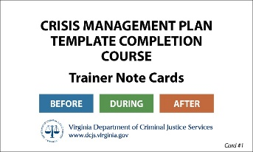
Content: CMP Training PowerPoint slides, including trainer commentary for each slide. Optional discussion questions are included throughout the presentation.
Index Cards: Index cards to assist trainers in highlighting
and reinforcing key topics during instruction.
Additional Resources:
The PDF document for the note cards and additional resources is available to download from the Virginia Department of Criminal Justice Services website at:
https://www.dcjs.virginia.gov/crisis-management-plan

This page intentionally left blank.

Units and Modules

UNIT 1 | Important Considerations BEFORE a Crisis | 60 minutes
Module 1 | Prevention/Mitigation, Protection, and Preparedness Strategies | 30 minutes
Module 2 | Planning and Practicing | 30 minutes
UNIT 2 | Important Considerations DURING a Crisis | 120 minutes
Module 3 | Incident Command System Planning | 30 minutes
Module 4 | Emergency Response Protocols | 30 minutes
Module 5 | Threat and Hazard-Specific Response | 30 minutes
Module 6 | Crisis Response Operations and Supporting Documents | 30 minutes
UNIT 3 | Important Considerations AFTER a Crisis | 60 minutes
Module 7 | Reunification | 25 minutes
Module 8 | Recovery | 25 minutes
 | Closing Questions | 10 minutes

This page intentionally left blank.

Set the Right Tone: Start your presentation with a relevant quote or surprising statistic that highlights the purpose and importance of the training. This helps underscore why participants are there. Take time to provide an overview of the presentation and consider asking attendees why they chose to attend and what significance the training holds for them.

Engaging Presentation Style: Avoid lecturing. Aim for an engaging, conversational style, and refrain from reading directly from the slides to prevent a “death by PowerPoint” experience. Use slides as a tool to guide your key points and keep the audience focused on your message. Remember, it’s you the audience should focus on—not the slides.

Relevance in Learning: Adults thrive in environments that connect to their experiences. Incorporating hands-on activities and realistic simulations can significantly boost engagement.

Collaborative Learning: Adults learn best when actively participating. Fostering group discussions and projects can enhance the learning experience and deepen understanding. Organizing breakout sessions allows participants to work collaboratively, promoting teamwork and enriching their grasp of the material.

Problem-Based Learning: Adult learning is most effective when driven by real-world challenges. Facilitating collaborative problem-solving activities that relate to participants’ experiences can enhance retention and understanding, making learning more meaningful.

Managing Challenging Participants: Dealing with “know-it-all” or challenging participants is common in training sessions. Rather than confronting them directly, create an environment that encourages open dialogue and values many perspectives. Acknowledge the expertise of the challenging participant and validate their contributions. Then, communicate the training program’s benefits and its positive impact on student and staff safety.

This page intentionally left blank.

POWERPOINT AND TRAINER NOTES

UNIT 1: BEFORE

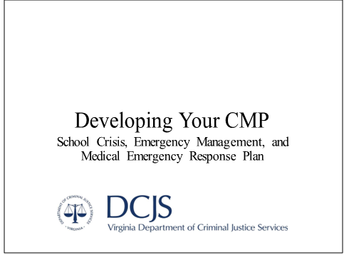
BEFORE Note Card 1
This training is intended to assist school and division leadership as they complete the DCJS School Crisis, Emergency Management, and Medical Emergency Response Plan template, also known as the CMP template.
This template was developed as a resource by the Virginia Center for School and Campus Safety in alignment with the Code of Virginia § 9.1-184.D to serve as recommended effective processes and procedures that align with state code and industry best practices. Unless otherwise noted as a requirement under the Code of Virginia, suggested actions should be tailored to align with local and regional emergency management plans and customized to fit school and/or division-specific needs.

This page intentionally left blank.

BEFORE Note Card 2
Unit 1: BEFORE
Important Considerations Before a Crisis

This unit of the CMP template training aligns with the BEFORE sections of the template, which cover federally recognized phases of emergency management that occur prior to an emergency, including prevention/mitigation, protection, and preparedness. It also provides an overview of the introduction section of the template.
Throughout the training, some content pertains only to the division-level plan. These slides are marked with a “Division Level” graphic in the lower right corner. While the information needed for school- and division-level plans differs, it is crucial for individuals responsible for completing these plans to understand the vertical alignment between them.
Group Discussion: How important is this training to you? What factors should we consider BEFORE an emergency occurs? How prepared do you think your school is?

Unit 1 HANDOUTS:
CMP Acronyms List
CMP template (School or Division version)
Drill Planning Chart
Information Needed for Template Completion (School or Division version)
Legislative Summary for Schools
Federal Emergency Management Agency (FEMA) Levels of Readiness Chart
Phases of Emergency Management Summary
Sample After Action Report (AAR)
Sample Drill Reporting Form
Sample Digital Maps
Sample Individual Safety Plan (ISP)
State School Safety Audit Timeline
TEAMS Handout

Information Needed for Completion

BEFORE Note Card 3
At the start of the template, there is a comprehensive list of all the information required to complete it. This includes names, maps, planning details, and other items specific to your division or school facility.
HANDOUT:
Information Needed for Template Completion (School or Division version)

INTRODUCTION
Setting up the CMP

BEFORE Note Card 4
The introduction section of the CMP template details the purpose, goal, and scope of the CMP. It reviews the legal authority and requirements for school divisions to create and maintain a CMP and outlines the distribution process once the CMP is completed.

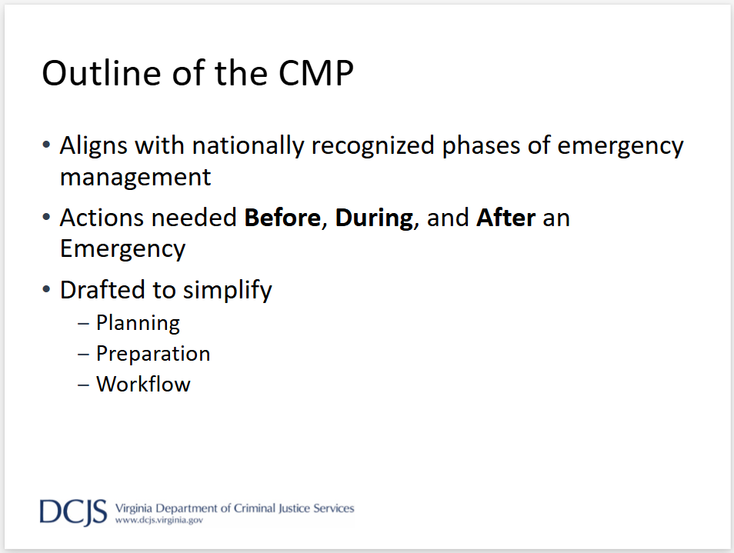

BEFORE Note Card 5
The CMP template addresses all phases of emergency management in three sections (BEFORE, DURING, and AFTER) to facilitate workflow, preparation, and consistency across the state.
National agencies may follow a four- or five-phase approach to emergency management (prevention/mitigation, protection, preparedness, response, and recovery).

Purpose, Goals, and Scope

BEFORE Note Card 6
When completing the CMP, it is crucial to understand its purpose and goals while maintaining a clear focus on its scope. Schools or divisions often have multiple plans in place, and the CMP should be designed to complement and support these existing plans, not duplicate them. While some content areas may overlap and cross-reference one another, the CMP should not override any other planning documents.
Group Discussion: What plans are already in place within your school? Division? Are you familiar with them all?
HANDOUTS:
Copy of applicable CMP template
CMP Acronyms List

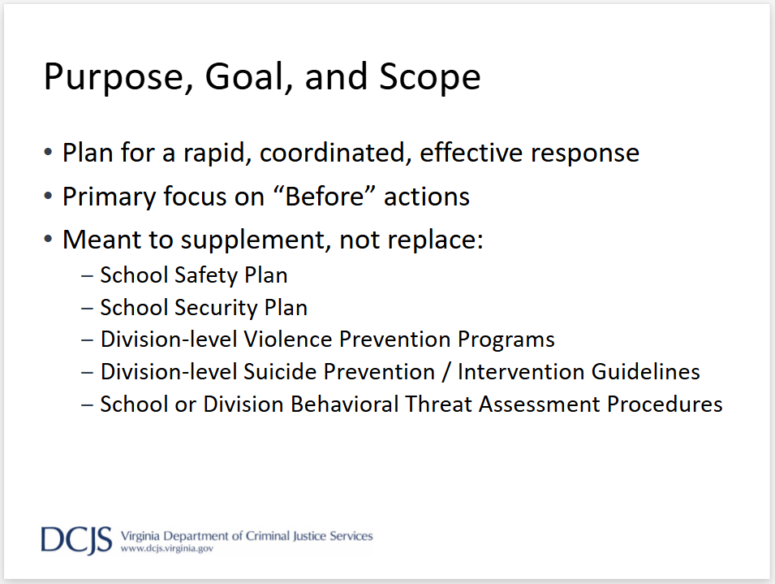
BEFORE Note Card 7
The CMP emphasizes strategies for preventing and preparing for all types of emergencies that could impact a school. Equal importance is placed on ensuring an effective and efficient response to and recovery from any crisis that may occur. The plan should be developed in alignment with local and regional emergency response or crisis management plans to ensure coordinated responses across all agencies.
Additional documents, plans, or procedure manuals may be created to address specific elements of the safety plan in greater detail. However, these supplementary materials should not override the information outlined in the CMP.

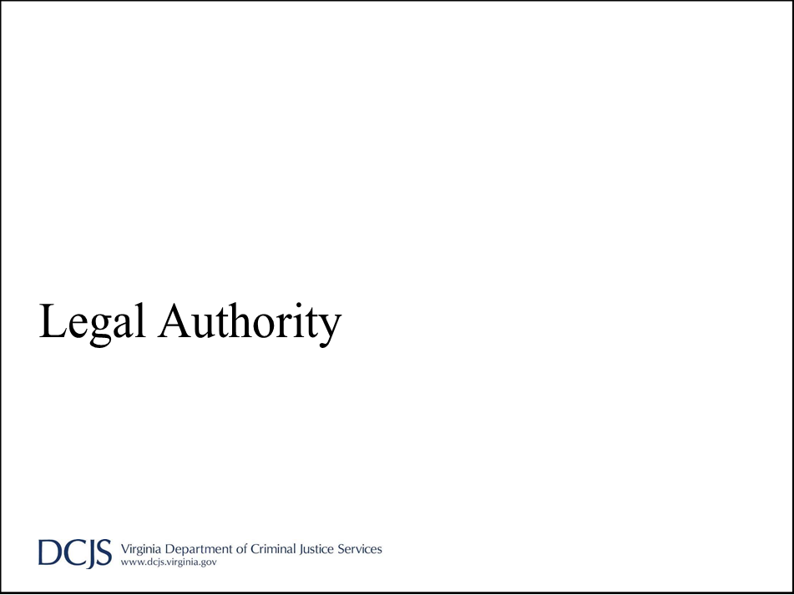

BEFORE Note Card 8
Sections of the CMP required by state code are identified. For sections of the template that are not legally mandated, suggested actions are provided. These should be tailored to align with local and regional emergency management plans and customized to meet the specific needs of the school and/or division.

Code of Virginia: Sections to Know
• § 22.1-279.8: School safety audits and school crisis, emergency management, and medical emergency response plans required

- § 22.1-137.3: School safety procedures; emergency situations; annual training

BEFORE Note Card 9
While the template includes a few additional sections of code that pertain to specific parts of the CMP, the next two slides highlight the primary legal reference points that govern most items in the plan.
A handout with all legal references used throughout the CMP template is available.
§ 22.1-279.8: “School crisis, emergency management, and medical emergency response plan” means the essential procedures, operations, and assignments required to prevent, manage, and respond to a critical event or emergency, including natural disasters involving fire, flood, tornadoes, or other severe weather; loss or disruption of power, water, communications or shelter; bus or other accidents; medical emergencies, including cardiac arrest and other life-threatening medical emergencies; student or staff member deaths; explosions; bomb threats; gun, knife or other weapons threats; spills or exposures to hazardous substances; the presence of unauthorized persons or trespassers; the loss, disappearance or kidnapping of a student; hostage situations; violence on school property or at school activities; incidents involving acts of terrorism; and other incidents posing a serious threat of harm to students, personnel, or facilities.”
The Code of Virginia § 22.1-137.3: “In addition to complying with the requirements for drills set forth in §§ 22.1-137, 22.1-137.1, and 22.1-137.2, each school board shall develop training on safety procedures in the event of an emergency situation on school property. Such training shall be delivered to each student and employee in each school at least once each school year.”
Code of Virginia: Sections to Know
(continued)
• § 22.1-137 and § 22.1-184: Details require drills to be completed each school year
‒ § 22.1-137 Fire Drills
‒ § 22.1-137.1 Tornado Drills
‒ § 22.1-137.2 Lockdown Drills
‒ § 22.1-184 School Bus Emergency Drills

BEFORE Note Card 9 (continued)
In addition to the legislative requirements, the Virginia State Fire Code and the Virginia Administrative Code have additional requirements related to emergency drill requirements. DCJS Guidance related to scheduling and planning drills takes all three sources into account.
HANDOUT:
Legislative Summary for Schools

Plan Development and Maintenance

BEFORE Note Card 10
Since no two schools or school division facilities are alike, a single generic plan or manual cannot encompass all the information needed to address every potential situation. Each facility should use the CMP template as a framework to develop a customized plan tailored to its specific needs.
The CMP template outlines relationships, responsibilities, and protocols, enabling school administrations to implement emergency management strategies that address their facility’s unique requirements while aligning with division, local, and regional plans. To support this process, state code identifies key strategic partnerships that should be integrated into the development of each plan.
Group Discussion: What unique circumstances does your school face in an emergency?

Planning Team
• Required to work with:
‒ Chief Law Enforcement Officer
‒ Fire Chief
‒ Chief of EMS Agency
‒ Executive Director of Regional EMS Council
‒ Emergency Management Official

BEFORE Note Card 11
The Code of Virginia § 22.1-279.8. (D) stipulates that “Each school board shall ensure that every school that it supervises shall develop a written school crisis, emergency management, and medical emergency response plan, consistent with the definition provided in this section, and shall include the chief law-enforcement officer, the fire chief, the chief of the emergency medical services agency, the executive director of the relevant regional emergency medical services council, and the emergency management official of the locality, or their designees, in the development of such plans.”

Contact Lists
- Administrators
- Safety Team
- School ICS Team

BEFORE Note Card 11 (continued)
To maintain an effective emergency plan, schools or divisions should also develop and regularly update a comprehensive contact list. This list should include key individuals who fulfill critical roles during an emergency. Suggested contacts are:
- Administrators: Include principals, vice-principals, and other leadership personnel.
- Safety Team members: Staff members designated to assist in the creation, updating, and implementation of the emergency plan.
- Incident Command System (ICS) Team: Individuals assigned specific ICS roles at the school or division level, such as incident commander, operations chief, logistics chief, or planning lead.
This contact list should be accessible, shared with relevant parties, and updated regularly to ensure accuracy.

Record of Updates and Revisions
- Updates can be made as needed
‒ Personnel change
‒ Resources available
‒ Local policy references
- Revisions should be made before annual review
‒ Legal/legislative requirements
‒ Change in protocols based on exercise or drill
‒ Emergency that reveals deficiencies or shortfalls
- Annual review of the plan must occur
‒ Superintendent must certify review to VCSCS

BEFORE Note Card 12
A record of any updates made throughout the school year or revisions made during the annual review should be documented in the CMP, along with the signature of the building administrator and/or division superintendent who approved the changes. Revisions made to the CMP should be incorporated into the plan prior to the planning team and school board’s required annual review. The Superintendent must certify the annual review to the Virginia Center for School and Campus Safety.
The Code of Virginia § 22.1-279.8. (D.) states, “The local school division superintendent shall certify this review in writing to the Virginia Center for School and Campus Safety no later than August 31 of each year.”

Plan Distribution
- Should be treated as confidential
- Distribution may be limited by school board
- Previous versions should be destroyed when updated

BEFORE Note Card 13
The CMP should not be shared beyond those with an official need to know. The plan contains sensitive information that requires safeguarding, including names and contact information of persons listed in the plan, key locations of people, assembly points, equipment, supplies, and facility operating devices. Copying, disseminating, or distributing any versions, supplemental documents, or graphics to unauthorized users may be limited by the school board. Plan holders are to be instructed to permanently destroy (by shredding, burning, or otherwise assuring destruction beyond recognition) outdated portions of the plan in accordance with school division policies relating to FOR OFFICIAL USE ONLY (FOUO) information. FOUO indicates that the materials are sensitive but not classified and should always be kept secure.
Group Discussion: Do you know where to find the CMP for your school? Have you read it?

Plan Distribution (continued)
- Division Level:
‒ Full copy
‒ Superintendent, Board, Principal
‒ Responding Agencies
- School Level:
‒ Full copy to Division leadership and responding agencies
‒ Abbreviated copy to staff and faculty
‒ Applicable sections to Relocation sites and MOU agencies

BEFORE Note Card 14
The Code of Virginia § 22.1-279.8 (D) grants local school boards “the authority to withhold or limit the review of any security plans and specific vulnerability assessment components as provided in subdivision 4 of § 2.2-3705.2.” As a result, some individuals may only receive specific portions of the CMP.
The superintendent is responsible for approving the plan and ensuring its dissemination in both electronic and hard-copy formats. Copies may be distributed to individuals, departments, schools, facilities, and organizations assigned responsibilities in the CMP.

This page intentionally left blank.

Module 1: Prevention/Mitigation, Protection, and Preparedness Strategies
Module 1
Prevention/Mitigation, Protection, and Preparedness Strategies

BEFORE Note Card 15
The first module of the BEFORE section covers actions that align with the federally recognized phases of emergency management: prevention/mitigation, protection, and preparedness.

Prevention
Actions taken to avoid an incident or to intervene to stop an incident from occurring
May include:
- Vulnerability assessments and corrections
- School climate and culture surveys
- Establishing communications procedures
- Policies related to building access
- Systems for student and staff accountability

BEFORE Note Card 16
The core of the CMP emphasizes preventing emergencies before they occur. This is achieved through ongoing evaluation and improvement, the development of systems and policies to reduce risks, and, if an incident does occur, the implementation of procedures to ensure a swift and effective response.
HANDOUT:
Phases of Emergency Management Summary

Mitigation
Sustained activities to reduce the loss of life and property by avoiding or lessening the impact of an unavoidable disaster
May include:
- Fencing hazardous areas
- Anchoring outdoor equipment that could become flying projectiles in high winds
- Bolting bookshelves to walls and securing loose wires

BEFORE Note Card 17
When evaluating mitigation factors, the goal is to identify measures that reduce the impact of unavoidable incidents and minimize the risk of loss of life.
Group Discussion: What mitigation factors are you aware of in your school? What still needs to be implemented?

Protection
Actions taken to safeguard all students, staff, assets, and critical infrastructure elements against threats and hazards
May include:
- Monitoring information related to physical or cyber threats
- Delaying, diverting, and halting perceived threats
- Using technological and cyber measures to control access to critical locations and systems

BEFORE Note Card 18
Protection factors primarily focus on safeguarding students, staff, assets, and critical infrastructure—delaying unauthorized access to resources and protecting systems essential for daily operations.
Group Discussion: How is your school currently protected?

Preparedness
Actions to ensure that all stakeholders can respond in a rapid, coordinated, and effective manner to help save lives and minimize damage
May include:
- Establishing Incident Command System
- Preparing emergency supplies and equipment
- Designating response areas of the facility
- Implementing drills, trainings, and exercises with fidelity that include students, staff, and first responders

BEFORE Note Card 19
Preparedness actions are designed to enable swift, coordinated responses with assisting agencies to save lives and minimize damage. A critical aspect of this phase is ensuring that staff and students are trained on how to respond in the event of an incident and that essential supplies and equipment are readily accessible in clearly identified locations.

Safety Team/Committee
- Membership
‒ Varying perspectives
‒ Knowledge of facility-specific needs
- Roles/Responsibilities
‒ Oversee safety for building
‒ Provide feedback on plan, drills, exercise, etc.
- Suggested additional training
‒ Incident Command System
‒ Delivery of Critical Incident Response curriculum
‒ Behavioral Threat Assessment overview training

BEFORE Note Card 20
Each facility should establish a Safety Team or committee familiar with the unique needs of the building. This team should include members from various roles (e.g., teachers, office staff, administrators, and extracurricular staff) to offer diverse perspectives on the CMP. The goals of the Safety Team are to provide feedback on the facility-specific plan, assist during drills and exercises to ensure effective implementation of response strategies, and serve as a safety point of contact for the building. Team members are encouraged to complete additional training, such as the self-paced Incident Command System courses offered by FEMA, and to be trained in delivering the Critical Incident Response curriculum to students, staff, parents, and community members.
At the division level, this team may be composed of department leads, executive leadership team members, or others designated by the superintendent and led by the designated Emergency Manager.
Group Discussion: Does your school have a Safety Team? Do you know who is on it? Do you know who to talk to about perceived threats or problems?

BEFORE Note Card 21
While there are no required sections to complete regarding the readiness level chart included in the division-level CMP, this is a brief overview of the chart and its purpose. These levels can be adjusted to align with local or regional readiness levels, ensuring consistent terminology across all plans. Each readiness level describes a specific state of preparedness, guiding actions at the division level to address a potential crisis.
Group Discussion: Is your division ready for a crisis?
HANDOUT:
Federal Emergency Management Agency (FEMA) Levels of Readiness Chart

Hazard Analysis
- Completing the Hazard Analysis
‒ Varying sources of data
‒ Use to guide response actions
‒ Use to guide drill/exercise development
- Continued Risk Assessment
- State Audit Process/Safety Inspection Checklist

BEFORE Note Card 22
The Building Safety Team/Committee should conduct and annually review a hazard vulnerability and risk assessment to identify strengths and weaknesses within the building and grounds, assess the school’s social, emotional, and cultural climate, evaluate available community and staff resources, and address the specific needs of individuals with access and functional requirements. To ensure a comprehensive plan is developed to effectively mitigate potential risks, multiple data sources should be analyzed during the hazard assessment.
Group Discussion: What hazard vulnerabilities does your school face? What are the strengths of your facility? How would you describe the cultural, emotional, and social climate of your school?
RESOURCE TEMPLATE: HAZARD ANALYSIS

Types of Hazards
- Natural
- Technological
- Biological
- Adversarial, Incidental, Human-Caused Threats
- Facility-Specific

BEFORE Note Card 23
Various types of hazards should be considered when conducting a hazard analysis. The CMP provides examples for each hazard category, along with sources for gathering relevant data points. The primary objective is to ensure that identified hazards are specific to the facility’s location, enabling the development of a tailored plan that addresses each hazard effectively with the appropriate resources.

Risk Identification
- Safety Assessment
- State School Safety Audit Process
- Behavioral Threat Assessment
- Anonymous Reporting

BEFORE Note Card 24
In addition to a formal hazard analysis, data from existing safety programs and past incidents can help identify risks, recurring trends, and other areas of concern. Schools should also utilize insights gained from the state audit process to strengthen their plans. Data from Behavioral Threat Assessment programs and anonymous reporting systems can be analyzed to identify trends over time, including those specific to grade levels or certain times of the year. An ongoing safety assessment process, combined with the state-mandated audit, offers valuable feedback that should guide future updates to the CMP.
HANDOUT:
State School Safety Audit Timeline

BEFORE Note Card 25
An essential component of preventative safety measures is the effectiveness and consistency of daily operations. Access control, which involves managing how individuals enter the property and building, and visitor management, which includes screening and admitting visitors, are critical to ensuring that only individuals with a valid reason are present on campus. These processes are often supported by the physical safety features incorporated into the school’s infrastructure.
Most decisions regarding these measures are made at the division level and are documented in policies or other operational guidelines.

BEFORE Note Card 26
Another way to enhance daily safety is by requiring identification badges for staff, visitors, and students.
Clear provisions and processes should also be established for granting after-hours or weekend access to the building for staff, determining the level of access and training provided to substitute teachers, and ensuring the safety of temporary, portable, and auxiliary buildings.
While most of these decisions are made at the division level and documented in policies or operational guidelines, school-level plans should specify the strategies implemented at their particular facility.
Group Discussion: How consistently are designated operations and security measures implemented in daily practices?
RESOURCE TEMPLATE: STAFF BADGE ACCESS

This page intentionally left blank.

Module 2: Planning and Practicing

BEFORE Note Card 27
The next training module moves beyond identifying hazards and risks, focusing on developing a response plan and its practical application to ensure its effectiveness.

Emergency Drills
- Type and Frequency
- Scheduling drills
- Documenting drills

BEFORE Note Card 28
We begin with emergency drills.
Group Discussion: What drills does your facility conduct? How frequently? Are they documented? Are they conducted with a sense of importance and seriousness?

Emergency Drills (continued 2 of 4)
- Know the Code: § 22.1-137, 8VAC20-70-110
- Type and Frequency
‒ Legislatively Mandated
  - Fire
  - Lockdown
  - Tornado
  - Bus Emergency Exit
‒ Recommended
  - Earthquake
  - Secure
  - Shelter

BEFORE Note Card 29
Certain drills are mandated for schools to complete under the Code of Virginia. While the legislative language specifically addresses emergency drills required for school facilities, best practices suggest that administration buildings should also participate in drills and exercises. This ensures all staff members are adequately prepared to respond effectively during emergencies. The CMP response actions for these drills should be reviewed annually by the Safety Team/Committee and updated as needed to reflect changes for the upcoming school year. For example, evacuation routes may need adjustments based on enrollment shifts in specific grade levels, or shelter areas might require modifications due to construction or maintenance projects.
To assist with planning, a chart is provided detailing the required number of drills, their types, and the specified time frames for completion. Additionally, beyond legislative requirements, the State Fire Code and the Virginia Administrative Code impose further regulations related to emergency drills. Guidance for scheduling and planning these drills incorporates requirements from all three sources.
HANDOUTS:
Legislative Summary for Schools
Drill Planning Chart

Emergency Drills (continued 3 of 4)
- Scheduling drills
‒ Varying days and times
‒ Inconvenient times
‒ Test certain areas of the building (cafeteria, gym, etc.)
- Documenting drills
‒ Maintain documents according to Division records policy
‒ Sample forms in Supporting Documents
‒ The Safety Team should complete an After-Action Review

BEFORE Note Card 30
Emergency drills should be scheduled at various times of the day and on different days to ensure that response actions are tested under diverse circumstances. At the school level, it is also recommended to design drills that evaluate responses during challenging scenarios, such as during class transitions, lunch periods, or in specific areas of the building—like evacuating the cafeteria or locking down the gym.
All drills should be carefully pre-planned with clear objectives or focus areas to evaluate. Safety Team members should assess whether the objectives were met and convene afterward to review the drill. This review process should identify areas of concern, propose improvements, and refine procedures to enhance overall preparedness.
HANDOUTS:
Sample AAR
Sample Drill Reporting Form

Emergency Drills (continued 4 of 4)
- Conducting trauma-informed drills
- Other types of practice:
‒ Tabletop exercise
‒ Functional exercise
‒ Full-scale exercise

BEFORE Note Card 31
While it is important to test response systems and protocols in a realistic manner, it is equally critical to avoid causing adverse reactions. Guidance on conducting trauma-informed drills, provided by the National Association of School Psychologists, can be found in the Resource Templates section.
In addition to traditional drills, facilities may consider alternative methods for testing and practicing response actions, such as tabletop exercises, functional exercises, or full-scale simulations.
www.nasponline.org/resources-and-publications/resources-andpodcasts/school-safety-and-crisis/systems-level-prevention/conducting-crisisexercises-and-drills

Emergency Supplies and Equipment
• Mapping
‒ Fire Safety Devices
‒ Mobility Aides
‒ Emergency Notification Systems
‒ Medical Response Equipment
‒ Eye Wash/Shower Pulls

BEFORE Note Card 32
To ensure an effective and coordinated response, responding agencies must have a clear understanding of available resources and their locations within the building. The items listed here can be compiled into a single comprehensive map or divided into specific categories, such as alarm activation points (fire and emergency notification), medical equipment (e.g., first aid kits, bleeding control supplies, AEDs), and additional aids (e.g., mobility assistance devices, eye wash stations). Regardless of how the maps are organized, they should be clearly marked and easy to interpret. It is strongly recommended that all buildings within a division use consistent symbols and colors across their maps, enabling responding agencies to locate the necessary resources quickly and accurately.
Group Discussion: Do you know what resources are available at your facility and how to access them quickly?
HANDOUT:
Sample Maps

Emergency Supplies and Equipment
(continued)
• Building-specific:
‒ Responding agencies who cover the building
‒ Emergency contact information for responders and utility providers
‒ Go Kit locations and contents

BEFORE Note Card 33
It is essential for staff to have and maintain up-to-date contact information for utility companies and agencies responsible for their location. This includes knowing designated contacts within these agencies and how to reach them in emergency situations. Staff should also be equipped with standardized Go Kits and be thoroughly familiar with their contents.
When gathering supplies and equipment, it is recommended to consult with local first responders. This ensures that any purchased equipment or acquired supplies are compatible with the agency’s tools and resources, allowing responders to be familiar with and trained in using what is provided.
RESOURCE TEMPLATE: GO KIT INVENTORIES

Medical Emergencies
- Traumatic Injury Response training
‒ Bleeding Control (e.g., Stop the Bleed)
‒ Crisis Response and Critical Care
- CPR/AED/First Aid
- Specialty Staff Trainings

BEFORE Note Card 34
The CMP allows schools to track which staff members are trained in various medical emergency response skills and which have additional certifications, such as Narcan and epinephrine administration, use of evacuation equipment, triage, and other crisis-response skills. The listed skills are not exhaustive, and any additional relevant skills identified among staff can be incorporated into the CMP.
Group Discussion: What medical response tools are available in your school? Do you know who is trained in emergency response skills?
RESOURCE TEMPLATE: STAFF SKILLS SURVEY

Individual Safety Plans
Exist for individuals with additional needs
- Functional needs: Mobility assistance, deaf/hard of hearing, visually impaired
- Access needs: Use of ramps or elevators instead of stairs
- Language needs: Second language learners
- Cognitive needs: Inability to respond independently
- Medical needs: Seizure activity, ancillary equipment, diabetic needs

BEFORE Note Card 35
An Individual Safety Plan (ISP) should be developed for any individual—staff member or student—who has additional needs that could affect their safety during the response or recovery phases of an emergency. The purpose of an ISP is to provide a personalized framework of specific, actionable steps that can be implemented by a designated individual to ensure the safety of the person it is designed for.
ISPs can encompass a broad range of needs, from mobility challenges and sensory sensitivities to medical requirements or behavioral considerations. The key characteristic of an ISP is its individualized approach, tailored to the unique circumstances of the person it supports. Although creating ISPs for all identified individuals may require significant time and effort, this proactive planning enhances emergency responses by reducing uncertainties and addressing potential obstacles in advance.
HANDOUT:
Sample ISP

Functional and Access Needs
- May be permanent
  - Identified physical disability
  - Physician diagnosed
- May be temporary
  - Surgical procedure
  - Temporary injury

BEFORE Note Card 36
Functional and access-related needs vary in duration, requiring ISPs to be adaptable. Temporary needs, such as those caused by surgery, injury, or a short-term medical condition, can be addressed through a temporary plan tailored to the individual’s specific situation. Once the person has fully recovered, the plan can be discontinued.
For individuals with permanent disabilities or chronic medical conditions, ISPs should be designed for long-term use, incorporating measures that address their ongoing needs. Regular reviews and updates are essential to ensure the plan remains effective and reflects any changes in the individual’s circumstances or requirements.

Assignments During a Crisis
- Individuals who need additional help are listed in CMP
- Staff assigned will be trained on how to best assist
- Backup staff may be trained on multiple individuals

BEFORE Note Card 37
All individuals needing additional assistance listed in the Crisis Management Plan (CMP) should be assigned both a primary staff member and a backup staff member. These assigned personnel should be trained in the individual’s specific safety plan.
During drills and exercises, both the primary and backup staff members should fully practice their response strategies. This ensures that actions can be carried out quickly and efficiently, and that all necessary equipment is available and functioning properly.
Backup staff can be assigned to cover multiple ISPs, but they must receive the same level of training and participate in all relevant drills. This approach ensures consistency, readiness, and the ability to provide support effectively, even if the primary staff member is unavailable during an emergency.
Group Discussion: Are you aware of all ISPs in your school? Do you know who is assigned to those individuals?

Developing the ISP
- TEAMS concept
  - Transportation and Mobility
  - Emotional/Mental/Behavioral Health
  - Auxiliary Communication
  - Medical Health
  - Security and Supervision

BEFORE Note Card 38
To develop an Individual Safety Plan (ISP) with effective strategies, the Virginia Safety Planning Guide for Individuals with Special Needs suggests using the TEAMS template. This framework ensures a comprehensive approach by addressing all critical areas necessary for emergency preparedness.
Key considerations for the ISP include:
- Will transportation need to send a bus with a lift?
- Do accommodations need to address known behavioral concerns?
- Will an interpreter be required to relay information or instructions?
- Are there medications or medical equipment that require supplies or a power source during off-site reunification?
- Is the individual known to elope frequently and require constant supervision in stressful situations?
HANDOUT:
TEAMS Handout

Documenting the ISP
- Include with IEP or Section 504 paperwork
- Individuals with temporary needs
- Crisis Management Plan
- Assigned staff members

BEFORE Note Card 39
Once a team has convened to develop the ISP, it should be incorporated into the student’s IEP documentation and reviewed during IEP meetings to ensure it remains accurate and up to date. For individuals who are not students or do not receive special education services through an IEP—such as those with a temporary ISP—the plan should be maintained in a similar manner. Relevant staff members should keep a copy of the plan on file and ensure it is accessible.
Additionally, all individuals regularly present on campus or assigned to the school with an active ISP should be listed in the BEFORE section of the Crisis Management Plan (CMP). This list should also include the staff members designated to assist them, ensuring that all necessary parties are accounted for in advance of an emergency.

This page intentionally left blank.

UNIT 2: DURING
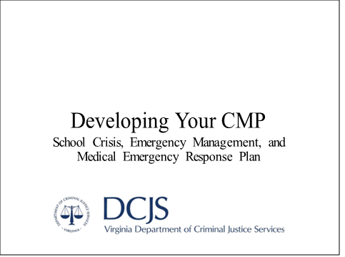

No Note Card
This training is intended to assist school and division leadership as they complete the DCJS School Crisis, Emergency Management, and Medical Emergency Response Plan template, also known as the CMP template.
This template was developed as a resource by the DCJS Virginia Center for School and Campus Safety in alignment with the Code of Virginia § 9.1-184.D to serve as recommended effective processes and procedures that align with state code and industry best practices. Unless otherwise noted as a requirement under the Code of Virginia, suggested actions should be tailored to align with local and regional emergency management plans and customized to fit school- and/or division-specific needs.

This page intentionally left blank.

DURING Note Card 1
This section of the CMP template training covers the federally recognized phase of emergency management called Response, which outlines all actions taken during an emergency.
Throughout the training, some content pertains specifically to only the division-level plan. These slides are marked with a “Division Level” graphic in the lower right corner. While the information needed for school- and division-level plans differ, it is crucial for individuals responsible for completing these plans to understand the vertical alignment between them.
Unit 2 HANDOUTS:
Building ICS Chart
SRP Overview Page
Roles and Responsibilities Chart
Sample Reunification MOU

This page intentionally left blank.

Module 3: Incident Command System Planning

DURING Note Card 2
At this stage, we move beyond merely identifying hazards and risks and focus on developing and practicing a plan to ensure an effective response. The first step is to identify key staff members at the school or division level who will take on additional responsibilities during an emergency.
Emergencies involve many moving parts, roles, and responsibilities that must be managed simultaneously to ensure a smooth and coordinated response. Having a clear plan in place and trained personnel ready to act is critical to achieving this goal.
Group Discussion: Are you aware of the Incident Command System (ICS)? Why is it important to you? How many of you know your role in the ICS?

DURING Note Card 3
Having an organizational system is essential to ensure everything operates in a coordinated and efficient manner. The Incident Command System (ICS) is a nationally recognized framework used by first responders to assign tasks, define scopes of responsibility, and enable an integrated response through a common language.
A brief overview of the ICS follows, along with an outline of the roles initially assigned to school staff during an emergency.
HANDOUT:
Building ICS Chart

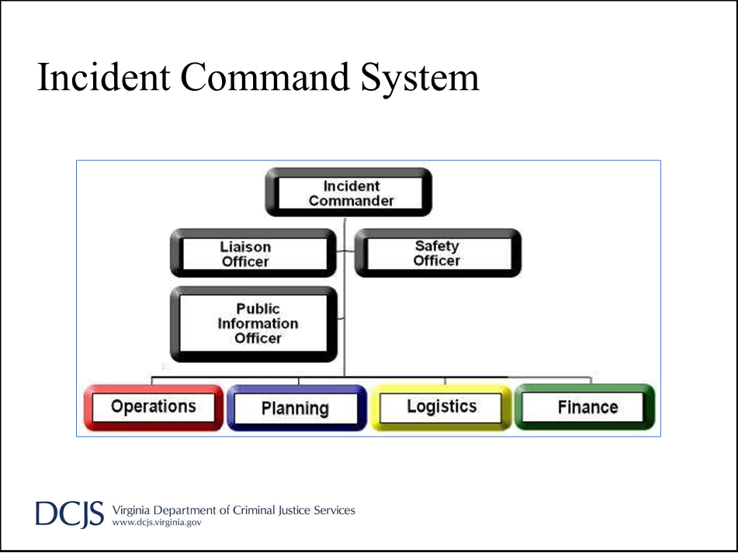

DURING Note Card 4
Each role and descriptor will appear together; click to advance to the next role.
The Incident Commander is responsible for overseeing and managing the entire response effort. They make key decisions, allocate resources, coordinate with involved agencies, and serve as the primary point of contact for the incident.

ICS Teams
Incident
Commander
Manage the Incident
Operations
Do Stuff
Planning
Plan Stuff
Logistics
Get Stuff
Finance
Pay for Stuff
DURING Note Card 5
Within the organizational framework of the Incident Command System (ICS), there are four main teams that provide information and feedback to the Incident Commander and relay decisions to their team members in the field:
- Operations: Do stuff – This team handles action-oriented tasks and includes departments such as Transportation, Facilities, Technology, and others.
- Planning and Logistics: Plan and get stuff – This team is responsible for coordination and resource acquisition, encompassing departments like HR, Purchasing, and Legal.
- Finance: Help figure out how to pay for stuff – This team ensures the financial aspects of the response are addressed.
At its core, ICS is designed to streamline communication and decision-making. Each of the four main branches is represented in the Emergency Operations Center (EOC) and may have teams or groups actively working at the impacted site, the reunification site, or both.
In addition to these branches, the ICS structure may include:
- Safety Officer: Ensures the working environment is safe for all personnel.
- Liaison Officer: Manages communication and coordination with external agencies.
- Public Information Officer: Handles the dissemination of information to media, parents, and the community.
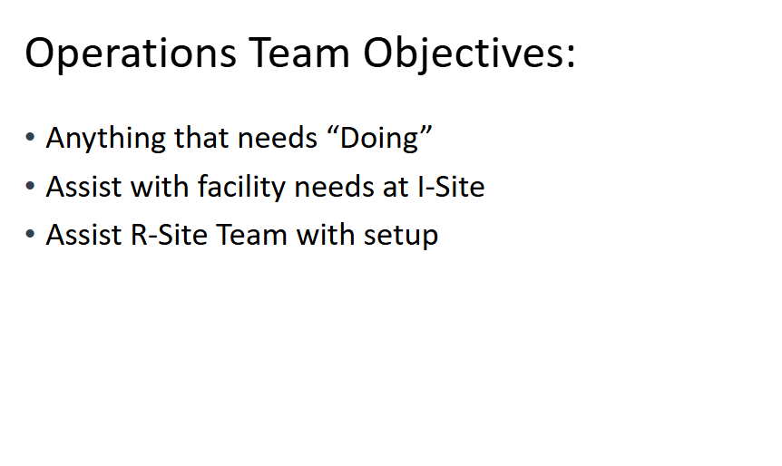

DURING Note Card 6
The Operations Team is responsible for carrying out the critical tasks during an emergency. Their primary focus is executing the work needed to manage the situation effectively. Key responsibilities include:
- Providing building access for first responders.
- Managing utilities at the impacted site, ensuring they are turned on or off as needed.
- Addressing technical issues, such as internet access or communication challenges.
- Assisting with the setup of the reunification process at the division level before students arrive.
The Operations Team ensures that essential tasks are completed promptly to support the overall emergency response.

DURING Note Card 7
The Planning and Logistics Team aims to stay two steps ahead of the situation. Their primary role is to anticipate needs and ensure resources are available when and where they are required. Key responsibilities include:
- Responding to requests for staff or supplies by determining where resources can be sourced and the fastest way to deliver them.
- Documenting all requests and maintaining organized records for final reports and potential reimbursement purposes.
Collaboration between school-level and division-level team members is often necessary to complete tasks. For example, while the school’s Operations Team might request buses to transport staff and students, the division-level Planning and Logistics Team would assign specific buses and drivers to fulfill the request.

DURING Note Card 8
The Communications Team (or Public Information Team) serves as the gatekeeper of information during an emergency. Their primary responsibilities include:
- Ensuring parents are promptly informed about when and where to pick up their students.
- Managing inquiries from the media.
- Posting timely and accurate updates as appropriate.
- Preparing and providing information for public release.
This team plays a critical role in maintaining clear and consistent communication with parents, the community, and the media during the crisis.

DURING Note Card 9
It is important to note that before first responders arrive on-site, building staff will need to take on critical roles within the ICS. While certain roles, such as the Public Information Officer, may be filled by division-level staff after initial information is communicated, there will still be numerous tasks on-site that need immediate attention from school staff.
The Building ICS Chart should align with staff’s usual responsibilities whenever possible to ensure a more efficient and effective response. This is because staff members are already familiar with the systems and processes they need to follow. For example:
- The nurse (or health services director at the division level) should be designated as the medical contact.
- The counselor should be assigned to oversee Care and Recovery.
- Teachers should be responsible for supervising their students during the emergency response.

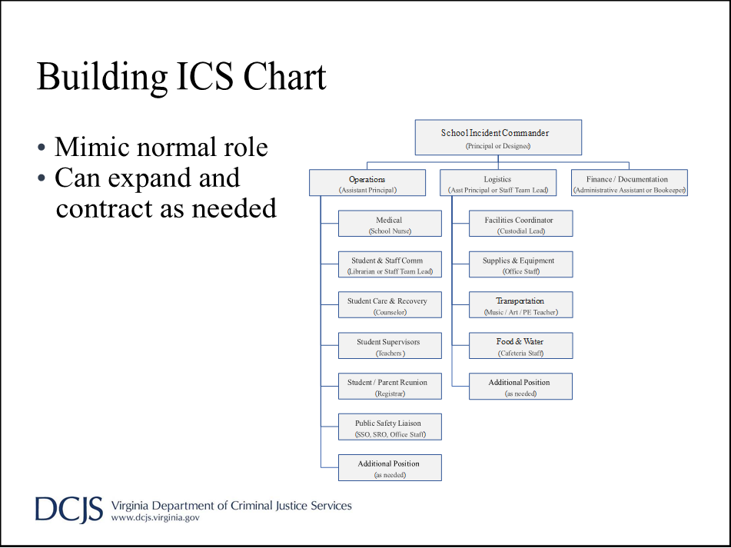

DURING Note Card 10
Some emergency roles may fall outside the scope of regular job duties but naturally align with certain positions. For instance, transportation oversight could be assigned to a staff member who interacts regularly with most students, such as a PE or art teacher.
At the division level, while not all roles in the ICS may be necessary—given that division-level facilities are primarily used by adults—specific responsibilities should still be assigned. These include managing medical needs, overseeing care and recovery, ensuring safety, and maintaining accountability during the emergency.

DURING Note Card 11
As first responders arrive on-site and/or division-level staff take over ICS roles from school-based staff, the situation transitions into a Unified Command. In this phase, multiple agencies work cooperatively to resolve the situation and coordinate response and recovery efforts.
Despite the collaboration, it is essential to note that the school retains primary responsibility for the well-being of its staff and students throughout the entire incident.

DURING Note Card 12
As you work through the CMP template, it is crucial to identify the responding agencies assigned to your school or division and establish points of contact within each agency. This will prove beneficial not only while completing your plan and participating in drills or exercises to test its effectiveness but also during an actual emergency, as you will know who to expect on-site.
Additionally, it is imperative to establish clear methods and points of contact between the school and responding agencies to address facility access during an emergency. For example, determine whether responding agencies have gate keys, access badges, or other tools to enter the facility if staff members are unavailable to grant access.
RESOURCE TEMPLATE: MUTUAL AID AGREEMENT SAMPLE

DURING Note Card 13
As we discuss the ICS and Unified Command, it is also important to highlight that an internal Continuity of Operations Plan (COOP) has been established at the division level. This plan ensures that essential functions can continue during and after an emergency.
The COOP should be developed collaboratively, incorporating input from city, county, or regional emergency management departments to ensure alignment and coordination with broader emergency response efforts.

DURING Note Card 14
Lastly, a clear chain of succession should be developed at both the school and division level and communicated to all involved individuals. This ensures there is no confusion about who is in charge when a disaster occurs.
At the school level, discussions should also take place to decide who will remain at the impacted site and who will accompany staff and students as they are transported to the reunification site, becoming the primary point of contact at the new location.
While the chain of succession may vary depending on the nature of the emergency, decisions should be made in advance to ensure clarity and preparedness when a situation arises.

This page intentionally left blank.

Module 4: Emergency Response Protocols

DURING Note Card 15
The State of Virginia has adopted the Standard Response Protocols as the best practice recommendation for a general building-level response during an emergency.

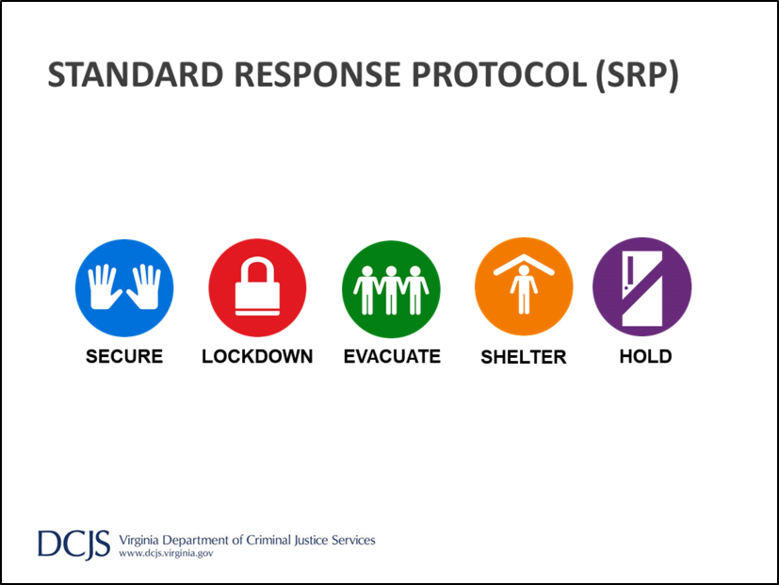

DURING Note Card 16
The Standard Response Protocol (SRP) is designed to be multi-hazard in nature. This means that, no matter the situation, one of these response protocols can be applied, allowing us to remember just five key actions rather than a specific response for every possible scenario. The SRP also uses plain language—there are no code words or colors to remember.
Let’s now look at each of the SRP actions, discuss when they would be used, and outline tasks assigned in the CMP to ensure that staff and students are prepared to act when each protocol is activated.
Each building may implement the SRP in slightly different ways to ensure it fits the specific setup and needs of the facility.
HANDOUT:
SRP Overview

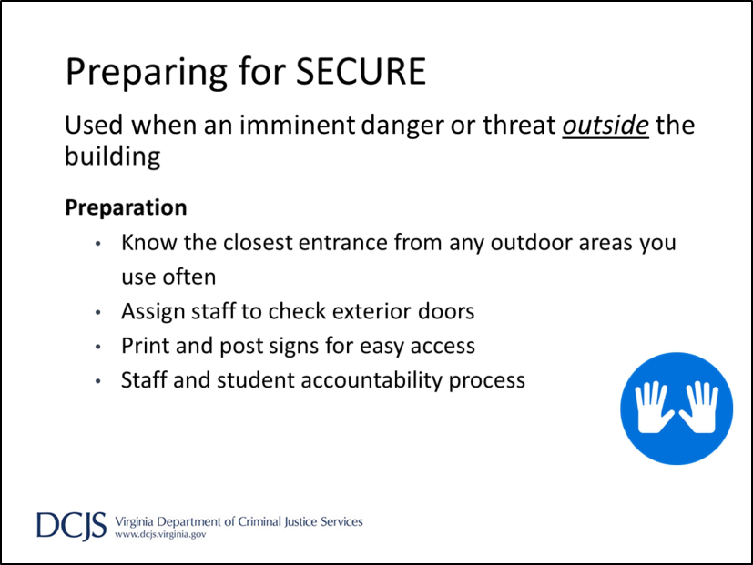

DURING Note Card 17
SECURE is exactly what it sounds like—when there is a danger outside the building that we want to prevent from entering, we secure the building to ensure no one can come in or leave. This could involve anything from an animal outside to first responders working in the neighborhood or an unknown individual on the property who refuses to leave.
To prepare for a SECURE, staff should be familiar with the quickest routes back into the building from commonly used outdoor areas, such as playgrounds, learning spaces, stadiums, parking lots, etc. Since the danger is outside during a SECURE, the goal is to get everyone inside the building immediately.
Additionally, assignments need to be made for each exterior door to be checked, with a sign posted to indicate that the building is secure. Signs should be stored near each door for quick access, and a backup person should be assigned for each door.
A chart of additional roles and responsibilities is available in the template, which outlines further staff assignments, including details on how the school will account for both staff and students.

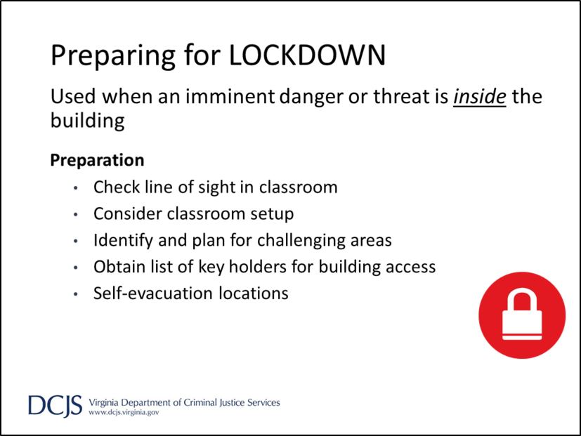

DURING Note Card 18
The next action is LOCKDOWN.
A LOCKDOWN is initiated by announcing:
“Lockdown — locks, lights, out of sight; Lockdown — locks, lights, out of sight.”
A LOCKDOWN is used when there is an immediate threat of violence inside the building. The primary goal is to ensure everyone is secure and protected from the danger.
LOCKDOWN can be initiated in response to an active attack or any other threat that has entered the building.
Preparing for LOCKDOWN requires more attention and planning, especially at the school level. Teachers should be encouraged to arrange their classrooms in a way that facilitates a quick move to a safe spot. Time should be spent assisting teachers as they determine where their classroom’s safe spot will be. Some strategies include:
- Closing the door and assessing visibility through the window.
- Moving from side to side to identify areas that are hidden from view, no matter where you stand.
- Using shelf units or furniture to create blind spots and block sightlines.

At the elementary level, teachers might designate a familiar area, such as the reading corner or story time rug, as the safe spot. By using language like “move to the rug,” students will have a clear and immediate action they can easily follow.
In larger common areas such as the gym, cafeteria, library, or meeting spaces, staff will also need to know where to move for safety during LOCKDOWN. Additionally, they should be familiar with self-evacuation gathering points in case LOCKDOWN is called, and they can safely exit the building. These points should be located away from the building, out of sight, and easily identifiable by first responders when they arrive.
As part of the LOCKDOWN planning process, a list of individuals with master keys should be included. This ensures that first responders know who to contact if they cannot access certain rooms or areas of the building during the response.

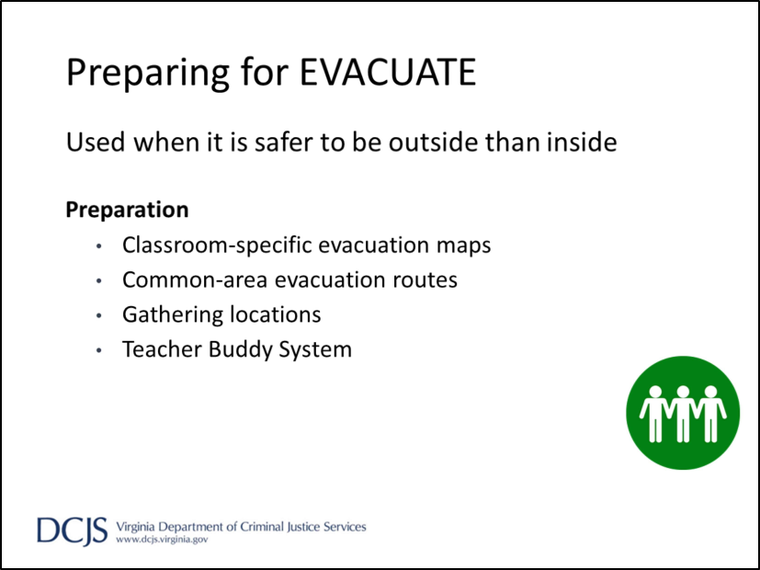

DURING Note Card 19
The next action is EVACUATE, which means we need to leave the building because it is not safe to stay inside.
The announcement for EVACUATE is:
“Evacuate — to a location. Evacuate — to a location,”
with the location being a pre-identified gathering area outside.
This is likely the action that everyone is most familiar with because schools have been doing fire drills for ages. However, fire is not the only reason to use EVACUATE. Anytime the outside is safer than the inside, such as when there is damage to the building, an issue like a broken water pipe, or a strong smell of gas, we will evacuate.
The main preparation for EVACUATE involves planning primary and secondary routes to avoid overcrowding in hallways and ensuring staff have an emergency Go Kit available.
Every room should have a map showing two ways to exit the building, a primary route and a secondary route in case the first route is blocked. Maps with building-wide directions should also be posted in all common areas, such as the cafeteria, gym, office, meeting rooms, and auditorium. These maps should include information about designated areas outside the building where everyone will meet, take attendance, and report back to administrators to ensure everyone is accounted for.
Gathering locations should be large enough to accommodate staff and students for accountability purposes until first responders or school division personnel provide further instructions. Additionally, two assembly areas should be identified where everyone can move in case transportation is provided to move off-site.
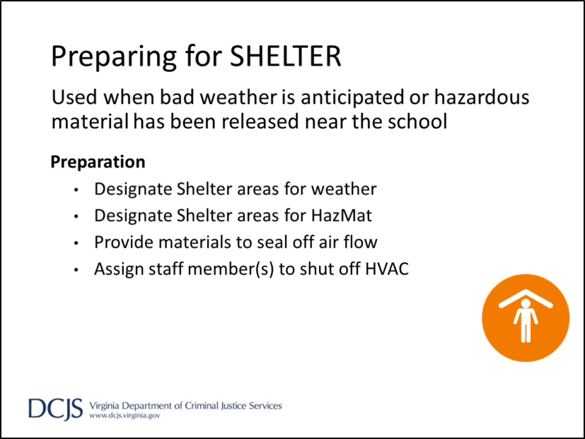
DURING Note Card 20
Our next strategy is SHELTER. We use SHELTER for two main reasons: bad weather and hazardous materials (HazMat). In either situation, there are designated areas in the building where students and staff will move to protect themselves from the hazard. When SHELTER is announced, it should include both the hazard, and the safety strategy needed.
For example: “Shelter for strong winds, move away from windows.
Shelter for strong winds; move away from windows.”
The second reason we would use SHELTER is for a HazMat incident, such as a train carrying hazardous materials derailing or a gas line being struck at a construction site. During a HazMat situation, assigned staff are provided with materials to cover windows and/or doors to prevent hazardous materials from entering the building. Certain staff members are also tasked with shutting off the HVAC system to avoid circulating hazardous materials throughout the building.
Shelter locations for both bad weather and HazMat situations should be determined based on the building layout, how quickly staff and students can move to the locations, and how easily the shelter can be secured by blocking vents or protecting individuals from potential hazards.
Some schools choose to have students and teachers remain in their classrooms during a HazMat SHELTER with enough materials provided to seal off doors and windows. Others may opt to move everyone into a main hallway and seal all exterior doors.

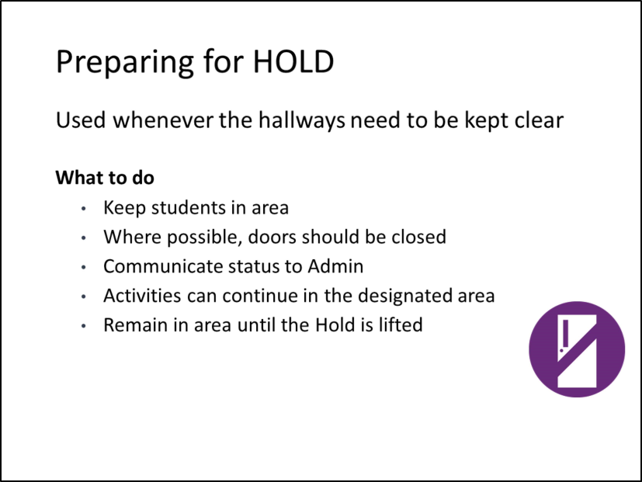

DURING Note Card 21
The last protocol is called HOLD, which means everyone stays exactly where they are until the emergency is over.
The announcement for HOLD is very clear: “Hold in your classroom or area. Clear the halls.
Hold in your classroom or area. Clear the halls.”
HOLD can be used during medical emergencies when hallways need to remain clear for first responders or when a situation with a student requires empty hallways until it is resolved, such as a fight or a behavioral issue.
There is no additional preparation needed for HOLD beyond training staff and students on how to respond when they hear the announcement.

Planning for Response Actions
- Roles and Responsibilities Charts
- Accountability
‒ Students
‒ Staff
‒ Visitors
- Staff Buddy System

DURING Note Card 22
Each Standard Response Protocol includes a list of assigned roles and responsibilities that should be completed. Some tasks, like notifying the alarm company that the fire alarm will be activated, are only applicable during drills. However, all actions should be assigned and practiced building muscle memory for real emergency situations.
The primary focus during an emergency is the accountability of students, staff, and visitors. A detailed plan should be developed to address how everyone will be accounted for, who will collect and reconcile that information, and what steps will be taken if someone is not accounted for.
Additionally, a staff buddy system should be established to ensure adequate supervision of students. This system can cover situations where there is a substitute teacher, a staff member is injured, or a teacher needs to attend to an individual student.
HANDOUT:
SRP Roles and Responsibilities

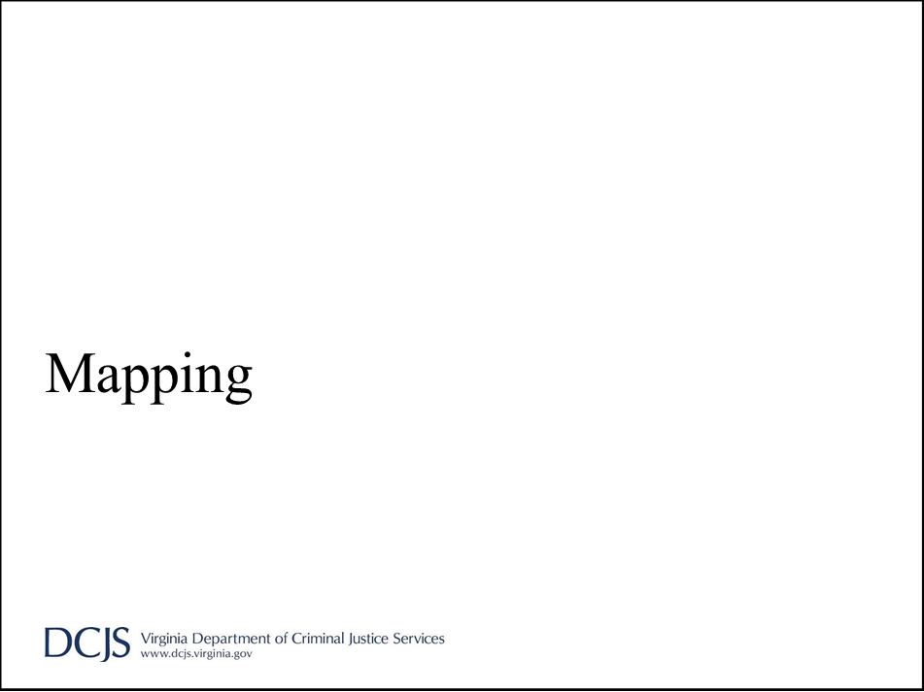

DURING Note Card 23
Throughout the CMP template, team members are required to provide copies of school maps to ensure they are properly developed and stored in a central location for easy access. We will now take some time to review each of the maps.
Group Discussion: Do you know what maps are available for your facility and where they are located?

DURING Note Card 24
We briefly discussed evacuation maps earlier. As a review, each room should have a map specifying both the primary and secondary evacuation routes for that particular room. These maps should be displayed near the main entry/exit point of the room and oriented with the building layout to prevent confusion during an evacuation. In addition, maps with general traffic flow directions should be posted in common areas, marking the nearest exit points for quick reference.
There should be consistency across all maps in the division, including the symbols and colors used. Avoid using symbols that could cause confusion, such as a red triangle, which is commonly associated with yielding. Consistency ensures clarity and helps everyone navigate effectively during an emergency.
For example: Primary routes should always be marked in red, secondary routes should always be marked in blue, and exits should be represented by the same symbol, such as a gold star.

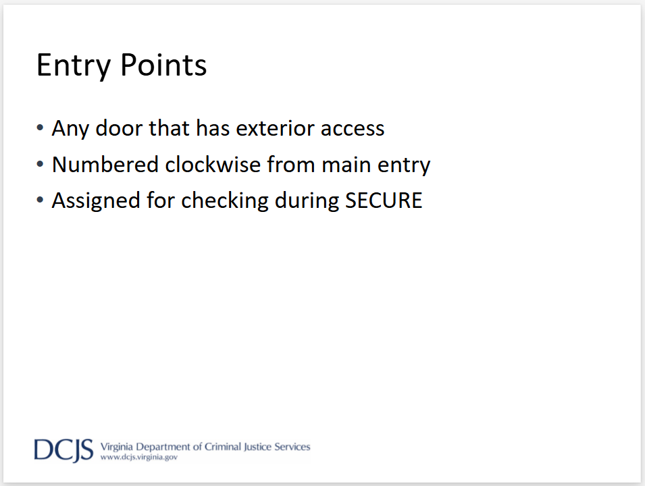

DURING Note Card 25

A building map should be maintained that identifies all exterior entry points providing access to the building. These entry points should be numbered, starting with 1 at the main entry and continuing clockwise around the map. The corresponding numbers should also be visibly placed on both the interior and exterior of each doorway.
These numbers serve two purposes:
- They correspond to assignments for checking doors during SECURE.
- They facilitate clear communication from inside and outside the building, allowing for precise directions or assistance requests at specific locations.
This system ensures efficiency and clarity during emergencies and routine drills.

Shelter
- Designated areas for weather
- Designated areas for HazMat
- May or may not be the same areas
- Marked on common area and classroom maps

DURING Note Card 26
Maps should also be created to provide directions to the nearest shelter from each individual classroom and common area. These maps can potentially be combined with evacuation maps by using different colors or symbols, such as an orange line to indicate movement paths to weather shelter areas and a green line for HazMat shelters.
If the school decides that staff and students will remain in their classrooms during a HazMat situation, this should be clearly indicated on the map to avoid confusion. Clear and consistent mapping ensures everyone knows the appropriate actions and routes in various emergency scenarios.

DURING Note Card 27
An overhead view map with imposed gridlines should be utilized to provide a clear orientation of the property. This map should include identifiable landmarks, such as those visible in a “Satellite View” image from Google Maps or CRG mapping.
The map should also mark:
- Utility access points or shut-off locations for water, gas, and electricity.
- General areas where water or gas lines are located, if known.
- Normal traffic flow patterns, indicating entry and exit points to the property.
This detailed map ensures that emergency responders and staff can quickly locate critical infrastructure and navigate the property effectively during an emergency.

Module 5: Threat and Hazard-Specific Response
Module 5
Threat and Hazard-Specific Response

DURING Note Cards 28–29
Module 4 focused on general response protocols that can be applied to any situation. This module will delve into more detail on specific threat- or hazard-based responses, which are required to be addressed individually in the plan per the Code of Virginia § 22.1-279.8.
As we review each threat or hazard, we will:
- Define the hazard,
- Provide an overview of planning suggestions, and
- Recommend actions to link the Standard Response Protocol (SRP) to threat- and hazard-specific planning.
Within the CMP template, you will find suggested actions, task checklists, and key points to consider. However, there are no sections requiring additional information or input. Instead, Safety Team members and staff with assigned ICS roles should become familiar with the information provided in each section.
To further assist planning, the SRP action most closely aligned with the recommended response is noted in the top-right corner of each section. In the CMP, these details are included under the primary SRP action that should be considered for each scenario.

RESOURCE TEMPLATE: THREAT-SPECIFIC RESPONSE CONSIDERATIONS
The Code of Virginia § 22.1-279.8:
“School crisis, emergency management, and medical emergency response plan” means the essential procedures, operations, and assignments required to prevent, manage, and respond to a critical event or emergency, including natural disasters involving fire, flood, tornadoes, or other severe weather; loss or disruption of power, water, communications or shelter; bus or other accidents; medical emergencies, including cardiac arrest and other life-threatening medical emergencies; student or staff member deaths; explosions; bomb threats; gun, knife or other weapons threats; spills or exposures to hazardous substances; the presence of unauthorized persons or trespassers; the loss, disappearance or kidnapping of a student; hostage situations; violence on school property or at school activities; incidents involving acts of terrorism; and other incidents posing a serious threat of harm to students, personnel, or facilities.”

Act of Terrorism
Terrorism is the unlawful use of force or violence against persons or property to intimidate or coerce a government, the civilian population, or any segment thereof, in furtherance of political or social objectives.
- Within the United States
- Within state/locally
Use SECURE


DURING Note Card 30
The first threat is an Act of Terrorism. The school’s response will vary depending on the location of the act:
- If the act occurs within the United States but poses no immediate threat to the state or area, the school should monitor the situation closely. Actions will be taken only if there is an indication that the threat could extend into the state or local area.
- If the act occurs within the state or region, the school may operate in SECURE mode as a precaution until it is confirmed that there is no indication of ongoing or escalating activity.

Active Attack
If a person displays a weapon, begins threatening students or staff with the weapon, or attempts to harm others with the weapon
- Move away from the area
- Do not allow the suspected individual to carry belongings
Use LOCKDOWN if a weapon is verified

Use HOLD if a weapon is reported while conducting a search

DURING Note Card 31
If an active attack occurs on campus, defined as a situation where a weapon is displayed and threats or attempts to harm others are occurring, LOCKDOWN should be initiated immediately.
If a weapon is not visible but threats of harm are being made, staff and students should be moved away from the potential area of threat. HOLD should be put in place while a search is conducted, with no movement allowed throughout the building until it has been verified that a weapon does not exist. In such situations, the person of concern should be separated from their belongings, and law enforcement should be notified to assist.

Flood
Consider a variety of sources that can cause flooding: heavy rains, dam failure, tropical storms, hurricanes, and broken pipes.
- Evaluate schools for probability
- Plan for potential relocation
Use EVACUATE for interior flooding



DURING Note Card 32
Planning for a flood should address all potential sources of flooding, not just natural events like dam failure or weather-related incidents. If those sources are unlikely, the plan should instead focus on issues such as utility failures or broken pipes. It should also include relocation plans for staff and students until repairs can be completed.
If flooding occurs inside the building, the primary response action will be EVACUATE to a designated location where transportation can be arranged to move everyone off-site.

Utility Failure
Important to have all utility providers and point of contact within the company on file.
- Principal determines needed protective actions
- Contact Utility provider
- Contact Division Maintenance department
Use EVACUATE for indoor gas leak or danger of fire during power failure

DURING Note Card 33
Utility failure plans may vary depending on the type and number of utilities present at each school. As part of the planning process, a list of utility providers, along with their points of contact and contact information, should be compiled and made easily accessible.
The principal or another administrator will determine any necessary protective actions, such as initiating EVACUATE for situations like an indoor gas leak, a broken water pipe, or other utility failures that make it unsafe to remain indoors.

Severe Lightning
In the event of a lightning threat, move all students and staff from outside, auxiliary, and portable buildings to the main building.
- Staff training: CPR, First Aid, AED
- All outdoor movement/activities suspended
Use SHELTER


DURING Note Card 34
When severe lightning is in the area, all students and staff should be moved as quickly as possible into the main building, and all outdoor activities or movement should be suspended or canceled. If the lightning is accompanied by continued bad weather or there is a potential increase in severity, SHELTER may be called to proactively move staff and students to secure locations.
Staff trained in the use of AED equipment, CPR, and first aid should be placed on standby for emergency response.

Tornado
A tornado is a violently rotating column of air in contact with the ground, visible as a funnel cloud. Thunder, lightning, heavy rain, hail, and strong winds often precede a tornado.
- Storm WATCH vs. WARNING
- Information sources
- All outdoor movement/activities suspended
Use SHELTER for initial response
Prepare for additional actions based on damage

DURING Note Card 35
It is imperative that administrators responsible for enacting Shelter operations understand and remember the difference between a WATCH (tornado possible) and a WARNING (tornado expected - seek shelter) and rely on trusted sources of information to make informed decisions.
As with severe lightning, staff and students should be moved into the main building, all outdoor activities and movement should be suspended, and SHELTER response should be enacted when necessary.
Staff should also prepare for additional actions based on the severity of the storm and any resulting damage. This may include the need for an EVACUATE response, transportation to an off-site location, and the activation of reunification protocols if the building sustains significant damage.

Bomb Threat/Suspicious Package
All bomb threats must be taken seriously until they can be assessed. The principal/CMT is primarily responsible for enacting any protective actions.
- DO NOT USE TWO-WAY RADIOS OR CELL PHONES
- Document threat on report form
- List of suspicious package characteristics
Use HOLD until credibility is determined
Use EVACUATE if indicated


DURING Note Card 36
When a bomb threat is received or a suspicious package is located, HOLD should be activated to allow time for gathering information and assessing the credibility of the threat. Avoid using two-way radios or cell phones, as these could trigger a remote detonator.
The principal or Crisis Management Team lead will be responsible for determining and enacting protective actions based on the report and in coordination with first responders. If EVACUATE is necessary, minimal routes should be used to exit the building to allow for an initial sweep ensuring the path is clear. Once outside, everyone should move as far away from the potential site as possible.
Group Discussion: What does your facility do when there is a bomb threat/suspicious package report? Do you know your specific responsibilities? Are you aware of the things you should avoid doing?

Medical Emergencies
Vary greatly in nature, scope, and needed response
- Never leave an injured person alone or unattended
- Notify 911 when in doubt of severity
- Do not move an injured person unless there is a threat to safety
Use HOLD to allow emergency services access

DURING Note Card 37
As with death or injuries, medical emergencies will vary widely in their scope and required response. However, certain primary actions should be consistent in all situations:
- Never leave the injured person alone.
- Notify 911 immediately if there is any doubt about the severity of the injury.
- Only move the injured person if there is an immediate threat to their safety, such as downed power lines, an ongoing threat of violence, fire, or similar hazards.
These actions ensure a prompt and appropriate response while prioritizing the safety of the injured individual.
HOLD should be activated to allow first responders to easily access the injured person.

Missing/Abducted Students
A student is considered missing any time they are unaccounted for at school, on school property, at a school activity, or while traveling to and from school.
- Define abduction/kidnapping
- From school property or activity
- Coordinating search
- Students with disabilities
Use HOLD while conducting the search

DURING Note Card 38
Your plan should clearly define the difference between kidnapping and abduction. Suggested language for these definitions is provided in the plan template and Support Documents section.
The plan should also specify that any time a student is unaccounted for—whether on school property, at a school activity, or while traveling to or from an activity—they will be classified as missing. The plan should include details about how the initial search will be conducted, the point at which law enforcement will be notified, and considerations for students with disabilities.
During the search, the building should be placed on HOLD to prevent the individual from being overlooked as they move around the building.

Trespasser/Unauthorized Person
An unauthorized person who enters school property and does not report to the office to follow visitor check-in processes is considered an intruder or trespasser.
- Verify their need to be on-site
- Follow the check-in process
- Encourage students and staff to report suspicious persons
Use HOLD if needed to investigate the situation
Use SECURE as needed

DURING Note Card 39
Visitor access protocols should be strictly followed by all individuals on-site. Anyone who does not have a legitimate reason to be on school property or inside the building should be asked to leave.
If an unauthorized person is being investigated, administrators may consider placing the campus on HOLD to limit interaction with the individual. SECURE may be initiated if the individual is acting suspiciously. If the individual is inside the building and becomes violent or threatens harm, LOCKDOWN should be initiated.
All staff and students should be encouraged to report suspicious persons immediately. Visitors should also be reminded to follow all protocols, including checking in, wearing a visible visitor’s badge, and checking out before leaving the premises.

Bus/Vehicle Crash
When possible, the principal or designee should respond to the scene of the crash. If it is not feasible, they should maintain constant communication with staff on-site.
- Communications Department
- Transportation Department
- Transport to hospital

DURING Note Card 40
Transportation staff will have specific protocols to follow in the event of a bus or vehicle crash. However, when possible, a member of the school administration team should be present at the scene to assist with:
- Supporting students,
- Contacting parents,
- Providing relevant information to first responders, and
- Maintaining accountability for everyone involved.
This presence ensures coordination and effective communication during the incident.
Death/Serious Injury
Response should be time-limited, problem-focused interventions to determine and disseminate accurate information, restore equilibrium, and support appropriate responses.
- Variations in student- or staff-related incident
- Attempted/completed suicide
- Planning for memorials/anniversaries

DURING Note Card 41
A death or serious injury will require variations in planning depending on the circumstances, such as:
- Whether it involved a staff member or student.
- Whether it was sudden or anticipated (e.g., due to a terminal illness).
- Whether the individual was a current staff member/student, a recent graduate, or a former teacher.
- How many staff or students were involved.
Planning for these situations should focus primarily on emotional support and recovery. This includes considerations for allowances around memorials, anniversaries, and remembrances, ensuring the school community has appropriate opportunities to process and heal.

Communications
- Internal notification of emergency
‒ School/Division staff
‒ Parents
‒ Pre-written templates
- External notification
‒ Responders
‒ Utilities
‒ Service Providers

DURING Note Card 42
Communication is a critical component during an emergency. Internally, staff must ensure that everyone is informed and able to carry out their assigned duties, parents receive clear instructions about where to go, and all information is thoroughly vetted before being shared. Using pre-written templates is recommended to minimize the time required for notifications.
Externally, the school system must be prepared to communicate effectively with utility providers, first responders, and other service providers, including community resources that may assist during the recovery phase. To streamline the communication process, a list of organizations and their contact information should be developed and regularly updated.

This page intentionally left blank.

Module 6: Crisis Response Operations

DURING Note Card 43
Module 6 covers considerations for operational details that apply to any response actions taken, including communications, staging areas, and key sites.
Group Discussion: How does your school communicate information during a crisis? Internally? To parents? To the public?

Methods of Communication
- Notification system
- School website
- Social media pages
- Paper copy of statements
- Local news sources

DURING Note Card 44
When communicating information about a building-specific incident, the planning team should consider all available channels to inform parents and relevant community members. These channels may include:
- Regular methods of communication, such as a mass notification system.
- Updates to the school or division website and social media pages.
- Providing information to local news outlets to assist with dissemination.
For younger grades, schools may also consider sending home paper copies of a written statement if the situation has already been resolved but parents still need to be informed.

Key Sites
- Emergency Operations Center
- Off-site reunification
- On-site reunification

DURING Note Card 45
In addition to identifying communication channels, schools should collaborate with division leadership to determine where and when an Emergency Operations Center (EOC) will be activated, as well as which staff members will be assigned to the EOC. These assignments should align with the ICS teams (Operations, Planning, Logistics, and Finance) to ensure consistency in communication and coordination.
Plans should also identify locations for reunification, whether through a modified dismissal process on-site or by moving students and staff to an off-site location. Whenever possible, it is recommended to use division property for reunification (e.g., relocating individuals from the middle school to the high school). However, schools should also establish contingency plans, including securing an MOU with community-based organizations, such as a church or civic center, to provide alternative options if needed.
HANDOUT:
Sample Reunification MOU

Staging Areas
- Transportation
- Supplies
- Media

DURING Note Card 46
Within each identified location, staging areas should be designated for specific purposes, including loading and unloading during transport, delivery and distribution of supplies, and providing a gathering point for members of the media to receive information.
When planning for reunification needs, a minimum of two sites should be identified: one within walking distance of the school and another located further away to reduce additional traffic on roadways near the incident.
Staging areas for media and supplies should be positioned to avoid interference with first responder operations and reunification drop-off or arrival points, ensuring smooth and efficient coordination during the emergency.

UNIT 3: AFTER

No Note Card
This training is intended to assist school and division leadership as they complete the DCJS School Crisis, Emergency Management, and Medical Emergency Response Plan template, also known as the CMP template.
This template was developed as a resource by the DCJS Virginia Center for School and Campus Safety in alignment with the Code of Virginia § 9.1-184.D to serve as recommended effective processes and procedures that align with state code and industry best practices. Unless otherwise noted as a requirement under the Code of Virginia, suggested actions should be tailored to align with local and regional emergency management plans and customized to fit school and/or division-specific needs.

This page intentionally left blank.

AFTER Note Card 1
This section of the CMP template training covers the federally recognized phase of emergency management called Response, which outlines all actions taken during an emergency.
Throughout the training, some content pertains specifically to only the division-level plan. These slides are marked with a “Division Level” graphic in the lower right corner. While the information needed for school- and division-level plans differs, it is crucial for individuals responsible for completing these plans to understand the vertical alignment between them.
Unit 3 HANDOUTS:
Reunification Staffing Chart
Standard Reunification Method Staging the Reunification Site, ADA accessible content for slide 18
SRM The Process in Six Easy Steps, ADA accessible content for slide 19
Essential Department Functions

This page intentionally left blank.

Module 7: Reunification
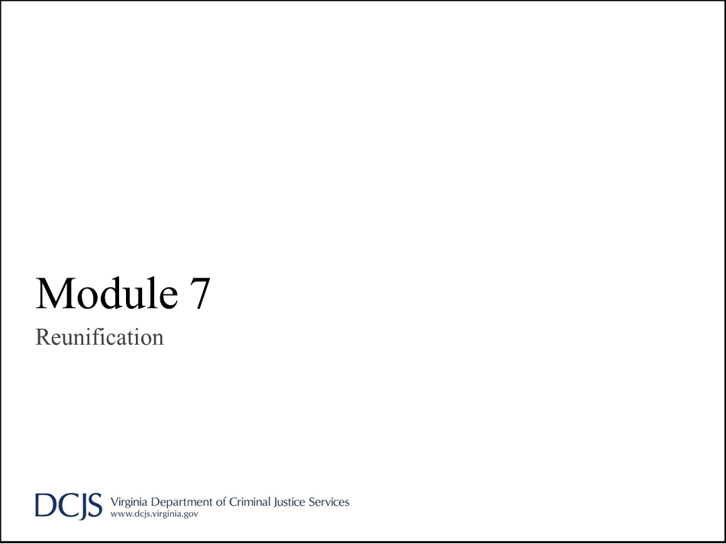

AFTER Note Card 2
The AFTER module of this training focuses on actions taken in the immediate aftermath of a crisis or emergency as the school or division works to resume normal daily operations as quickly as possible.
Reunification can take place on-site if the emergency permits. In such cases, the regular pick-up process may need to be modified by identifying alternate locations to facilitate the reunification process. It is essential to avoid using standard dismissal procedures, as maintaining student accountability is critical during an emergency.
Group Discussion: What are the challenges of reunification at your school?

AFTER Note Card 3
There may be times when your school is called upon to serve as a reunification site for another school. In these cases, normal dismissal procedures may need to be adjusted to accommodate the influx of parents and students, or an early dismissal may be appropriate to clear the site before the impacted school arrives. It is important to have a pre-mapped plan indicating where arriving students and parents will be reunified to avoid conflicts with your own processes.
If an off-site reunification is required, clear information should be provided at the entry point to the school property, and/or a staff member should be assigned to distribute details about where students have been transported. Additionally, the division-level communications team will send out instructions to parents and guardians regarding the reunification location and procedures.

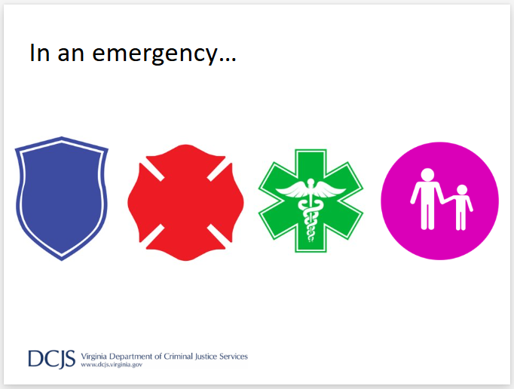

AFTER Note Card 4
Let’s do a quick review of the process.
There are a lot of moving parts immediately following an emergency, but with the occasional exception:
Police own the crime
Fire owns the flames
Paramedics own the injured
Schools own the kids (people)

Objectives:
- Every student is accounted for
- Every staff member is accounted for
- Every visitor is accounted for
- Every student is reunited with their parent/guardian

AFTER Note Card 5
During the reunification process, our objectives are:
- Every student is accounted for.
- Every staff member is accounted for.
- Every visitor is accounted for.
- Every student is reunited with their parent or guardian.
Reunification may take place at the impacted site if it can be safely facilitated without interfering with first responders. However, if the site is unsafe, or if rescue or recovery operations are ongoing, students and staff will be transported to an alternative location, such as another school or a non-division facility.
As discussed in the DURING section, MOUs should be in place with any non-division-owned property. These agreements should clearly outline the responsibilities of each team to ensure the reunification process runs smoothly.

Reunification Process
- Division
- Students/Staff
- Parents

AFTER Note Card 6
Let’s walk through each part of the reunification process. We’ll navigate between the Emergency Operations Center (EOC), the Impacted Site, and the Reunification Site to demonstrate how the various components work together.
First, let’s clarify what each site represents.

Division-Level ICS Team
Location: Emergency Operations Center
- Direct response actions
- Coordinate Reunification site
- Communicate with Transportation

AFTER Note Card 7
The EOC will serve as the central hub for the incident as it transitions into the reunification process. While activities will still require oversight and direction at the impacted site, the primary focus will shift to setting up and preparing the reunification site before notifying parents of the location.
Ideally, division-level staff will handle most of the setup and operations at the reunification site, allowing school-level staff to concentrate on their students. The EOC will facilitate all information flow, including information about coordinating transportation and communication with parents or guardians. All communications and decisions will go through the EOC to ensure consistency and efficiency.
Timing is critical to managing traffic flow, safeguarding information, and ensuring the reunification process runs smoothly and efficiently.

School-Level ICS Team
Location: Impacted Site
- School where the incident occurred
- School staff fill most of the roles initially
- Small team from division
- First responder presence

AFTER Note Card 8
Depending on situational factors, such as an active attack, a significant number of injuries, or extensive damage to the building, the impacted site may be particularly challenging to manage.
The site will likely be busy with first responders, public officials, and various other operations. Initially, the building’s ICS team will handle critical roles, but they may be relieved by first responders or division staff as they arrive.
Key concerns at the impacted site include addressing security, facility, staff, and student needs. Additionally, there will likely be a high volume of phone calls from parents seeking information. Managing these moving parts requires clear communication, coordination, and prioritization.
Remember - Our primary focus is on our staff, students, and visitors.
Police own the crime
Fire owns the flames
Paramedics own the injured
Schools own the kids (people)
Select Reunification Site
Division-Level Lead; School-Level Support
- Division-controlled facilities when possible
- Agreements with outside facilities
- Setup is critical

AFTER Note Card 9
The Reunification Site is where students are reunited with their parents and/or guardians. Once the school division determines that reunification is necessary, a site will be selected based on the situation, and the reunification team will be dispatched to begin setup and preparation for the arrival of students and, later, parents.
School staff will play a supporting role in the reunification process, as they are the ones most familiar with their students and families through daily interactions. While the process may take time, it is essential to ensure the system is set up correctly from the start so that it runs smoothly and effectively.

Immediate Response
Location: Impacted Site
- Activate the response protocol needed
- Contact division
- Gather at the on-site meeting location

AFTER Note Card 10
When an emergency occurs, response protocols are initiated to address the immediate situation. Once the emergency is under control or it is safe to do so, the individual designated as the incident commander on the building ICS chart should communicate with division-level staff to provide details about the situation. This information will help the EOC determine the best course of action for reunification.
Depending on the circumstances, each building has multiple pre-identified gathering locations where students, staff, and visitors can assemble while waiting for transportation to arrive.

Preparing for Reunification
Location: Emergency Operations Center
- On-site or off-site reunification
- Dispatch transportation
- Activate Reunification Team

AFTER Note Card 11
At the EOC, a decision will be made regarding reunification, including selecting the location for the process.
If transportation is required, it will be dispatched from the EOC and communicated to the impacted site team so they can prepare for loading.
Simultaneously, the reunification team will be activated to begin setting up the reunification site.

Preparing for Transport
Location: Impacted Site
- Account for students, staff, and visitors
- Transportation arrives
- Reunification process begins

AFTER Note Card 12
Once everyone has moved to the designated meeting location at the impacted site, students, staff, and visitors should be accounted for to ensure no one is misplaced while preparing for transportation.
As buses are loaded, a copy of the complete list of students, staff, and visitors should be sent on the first bus, so it arrives at the reunification site with the first group of people. Upon arrival, a student accountant will be responsible for verifying that everyone on the list has arrived at the reunification location.

Setup and Preparation
Location: Reunification Site
- Drive-through or walk-up process
- Determine student holding location
- Determine family support location
- Set up check-in/ID-check stations
- Establish traffic flow with cones/signs
- Station officers around the site for security/traffic assistance

AFTER Note Card 13
As the reunification process begins, the reunification team determines whether the site and situation are better suited for a drive-through or walk-up process. For example:
- If there is ample parking but limited space for a vehicle line, parents may be directed to park and come inside the building to pick up their student.
- Conversely, if indoor space is inadequate to provide privacy for medical treatment or counseling separate from the student holding area, parents should not be allowed inside.
- A drive-through process might also be more suitable for older students who can easily recognize their family vehicles.
Once the process is determined, setup can begin. Every adult arriving to pick up a student must have their identification verified to ensure they are authorized to do so. Student safety is the top priority, and it is critical to ensure that students are released to the correct adult.
A clear traffic pattern with signage and cones to direct drivers should be established, especially for a drive-through process. Whenever possible, additional officers or security personnel should be stationed around the main entrance and exit, the student holding area, and the check-in stations to help manage traffic flow and maintain order. Emotions will be high, and stress levels will be elevated throughout the process. It is important to plan for these factors, as people may not handle the situation calmly or effectively.

Reunification Team Assignments
- Checkers
- Reunifiers
- Accountants
- Class leaders
- Greeters, interpreters, floaters

AFTER Note Card 14-15
The Reunification Team primarily consists of division-level staff directing the process, with school-level staff providing support as needed and as available.
The key roles within the team are:
Checkers: These individuals verify identification and custody. They should be familiar with students and parents, be trained in the division’s visitor management system, or have access to student records. Front office staff members are ideal for this role due to their familiarity with the school community and processes.
Reunifiers: These are runners who locate students and bring them to their parent or guardian. A critical part of their role is to ask each student, “Do you feel safe leaving with this person?” before completing the reunification.
Accountants: There should be at least two accountants:
  - One to verify that all students have arrived at the reunification site.
  - Another to document when each student leaves and who they leave with, and to record this on the student check-out card.
Accountants need to be detail-oriented and capable of multitasking, as they ensure proper tracking throughout the process. Additional individuals can assist in this role, but clear communication is essential to avoid confusion or errors.
Class leaders: Teachers should remain with their class throughout the process. If a teacher is unavailable due to injury, involvement at the impacted site, or assignment to another role, buddy teachers or classroom aides can assist with their class.
To support the process without overcrowding, additional division-level staff members can serve as:
- Greeters to welcome parents and guide them through the process.
- Interpreters to assist non-English-speaking families.
- Floaters to distribute reunification cards, answer questions, and provide general support.
Administrators should not be assigned specific roles. If they are not required to stay at the impacted site, they should remain flexible and move around as needed. Administrators are the face of the campus, and their visibility is important for reassurance and communication with students and parents.
HANDOUT:
Reunification Staffing Chart

Parents
- Notification from the Communication Department
‒ Incident information
‒ Next steps
- Reunification instructions
‒ When and where
‒ Bring ID

AFTER Note Card 16
By the time students are ready to be moved, parents will have been notified of the situation and provided with instructions on where to go, what to bring, and what to expect during the reunification process.
If possible, a school staff member should remain at the impacted site, near the main entrance, to distribute printed copies of the same information to any parents who arrive on-site.

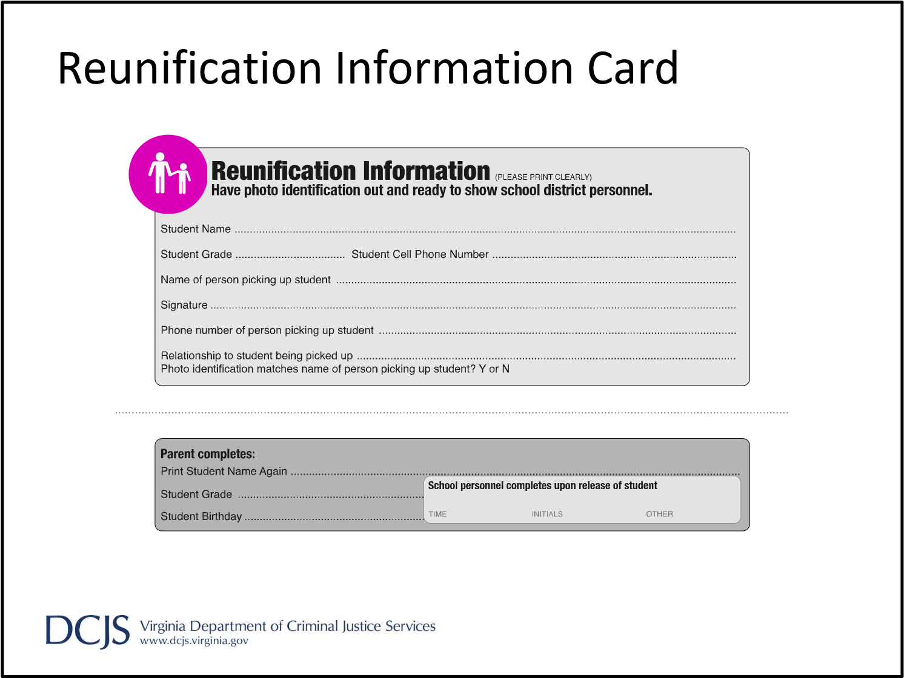

AFTER Note Card 17
When parents arrive at the reunification site, they will be given a card to fill out. The Standard Reunification Method card is an example of what this card may look like; however, your division may use its own method to gather the same information. Digital platforms can also be utilized to facilitate this process.
One card should be completed per student to ensure full accountability during the reunification. At the end of the process, these cards will serve as a record of who picked up each student, the time of pickup, and which staff member verified the release.

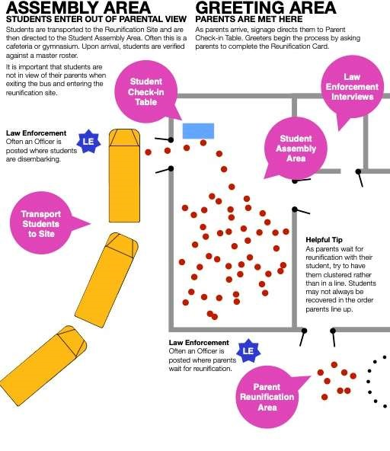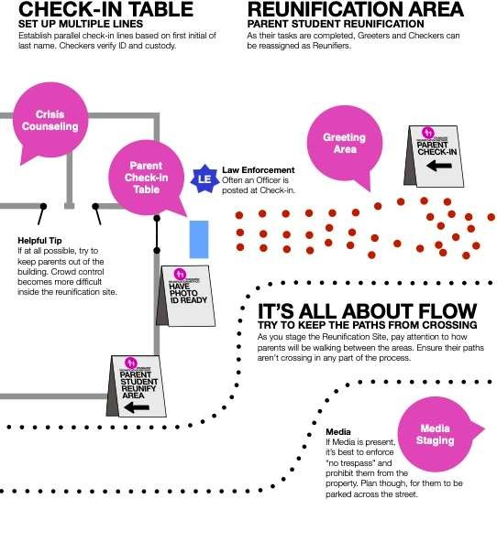
SRM: Staging the Reunification Site

AFTER Note Card 18
Using these images from the “I Love U Guys Foundation” SRM Operational Guidance v3 manual, here is an overview of the setup and process:
- Whenever possible, students and parents should arrive at opposite sides of the building. If this arrangement is not feasible, parents should be held off-property until all students have arrived and are safely inside.
- Students are moved to the assembly area while parents enter the check-in area to begin their part of the reunification process.
- Separate spaces should be designated for law enforcement interviews and crisis counseling teams to meet with families as needed.
This setup ensures a structured and secure environment for both students and parents throughout the reunification process.

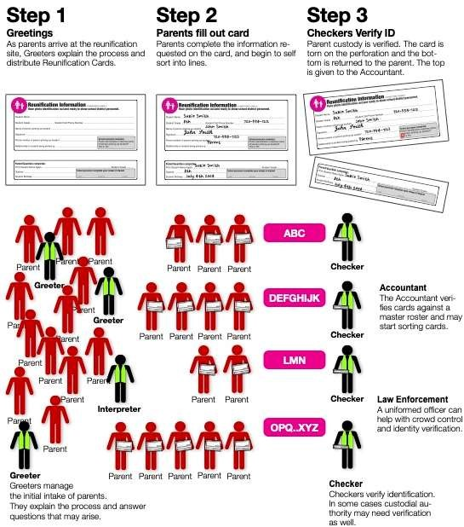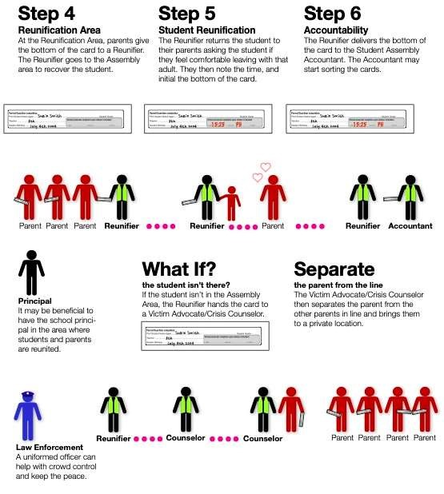
SRM: The Process in Six Easy Steps

AFTER Note Card 19
Once everything is set up and ready, parents arrive and complete a card for each student. Their ID is verified, and the first accountant confirms whether the student is on-site.
- If the student is not on-site: The parent or guardian is directed to speak with law enforcement or a member of the crisis counseling team, who will provide information about the student’s location (e.g., transported to a local hospital, etc.).
- If the student is on-site: The reunifier locates the student, asks them if they feel safe leaving with the adult, and then facilitates the connection. Once the student is reunited with the adult, they leave together, and the second accountant records that the student has completed the reunification process.
This process ensures accountability and provides appropriate support for families in all scenarios.

Reunification Pre-Planning
- Division Level:
‒ Setup team
‒ Reunification team supervisors
‒ Transportation needs
‒ Locations
- School Level:
‒ Reunification team support

AFTER Note Card 20
Here are the things that must be planned for in the CMP template.
We would encourage you to take the full SRM training through the I Love U Guys Foundation and make use of the detailed job aides and checklists on their website.

This page intentionally left blank.

Module 8: Recovery
Module 8
Recovery

AFTER Note Card 21
The last section of the AFTER unit covers items that should be addressed to move the division or school back toward normal daily operations.
A lot of these actions are primarily conducted at the school level, but developing the process and procedures may require input or feedback from division-level staff members.

Purpose, Goals, Focus
- Short-term actions
- Long-term goals
- Incident reporting
- Memorial/anniversary remembrance

AFTER Note Card 22
As your team transitions toward resuming daily operations, attention must be divided between short-term actions, long-term goals, incident reporting, and planning for memorials, anniversaries, or remembrance events. Balancing these priorities ensures that the school or division moves forward effectively while addressing the needs of the community.
- Short-term actions include identifying facility needs, determining academic priorities to resume learning, providing emotional support for students and staff, and assessing inventory needs.
- Long-term goals may include addressing building repairs, managing financial reimbursement, submitting state-required reporting, and replacing lost or damaged items.
- Incident reporting will likely involve submissions to various agencies at the local, state, or national levels, depending on the situation and the needs identified after the incident.
- Memorials and remembrance events require decisions about the level of support and resources the school or division will allocate toward activities such as plaques, ceremonies, or other commemorative efforts.

Counseling/Support
- Trauma-informed strategies
- General or group counseling
- Referrals to outside resources
- Supporting students experiencing homelessness or DSS placement
- Standardized process to ensure continuity of services

AFTER Note Card 23
When addressing counseling and support needs for staff and students, schools should implement a triage process to determine appropriate levels of care. This process should identify individuals who would benefit from group services, those requiring individual services, and those needing referral to external resources if their needs extend beyond what school staff can provide.
Special care and attention should be given to students requiring additional services if the campus is displaced for an extended period. This includes students experiencing homelessness or those in DSS care.
Additionally, a process should be in place to ensure continuity of care for students who were receiving support services prior to the incident, guaranteeing that these services remain accessible during and after recovery.

Facilities and Transportation
- Building needs
‒ Repair
‒ Replacement
‒ System records
- Transportation needs
‒ Status of bus fleet and reserves
‒ Road issues in the area
‒ Alternate pick-up/drop-off points

AFTER Note Card 24
When addressing the physical needs of the school or division, it is important to evaluate what can be repaired versus what requires complete replacement. This prioritization will help establish short- and long-term recovery objectives.
Throughout the recovery process, all system records (e.g., fire suppression, burglary alarms, kitchen equipment) must be maintained. This ensures that all systems are properly inspected, repaired, and fully functional before being returned to service.
For transportation, staff should maintain an inventory of all vehicles, noting which are available for use and which need repair or replacement due to the incident. In cases of natural disasters, transportation staff must also track daily road conditions to identify potential route changes or alternate pick-up and drop-off points until repairs are completed.

Contracts and Agreements
- Off-site reunification sites
- Transportation backups
- Agency MOUs
  - SROs and/or other law enforcement services
  - Counseling services

AFTER Note Card 25
Any contracts or external agreements should be systematically stored alongside the Crisis Management Plan (CMP). These agreements play a vital role in ensuring smooth coordination during emergencies. Examples include:
- Reunification Sites: Agreements with locations designated for reunifying students with families.
- Transportation Services: Contracts with external companies to provide transportation if internal resources are insufficient or unavailable.
- Community Resources and Agencies: Memorandums of Understanding (MOUs) or Mutual Aid Agreements (MAAs) with community partners such as local emergency services, shelters, or non-profits to support crisis response efforts.
Storing these agreements with the CMP ensures they are easily accessible to those managing emergency responses. Regular reviews and updates of these documents are essential to maintain their validity and relevance.
Academic Recovery
- Account for missed days/minutes of instruction
- Verify and validate grades/transcripts
- Coordinate with state testing agencies
- Coordinate with College Board testing centers
- Secure educational materials or substitutions

AFTER Note Card 26
In addition to physical recovery, academic recovery should begin as quickly as possible. This includes:
- Accounting for missed instructional days or minutes.
- Assessing the impact on grades and transcripts, particularly for graduating seniors.
- Reviewing and rescheduling any upcoming state or college testing dates, if necessary.
- Securing instructional materials to support students and staff until regular classroom instruction resumes.
Prioritizing academic recovery ensures minimal disruption to students’ educational progress and helps maintain their academic trajectory.
Essential Departments and Functions
- Human Resources
- Business Office
- Purchasing Department
- Child Nutrition
- Health Services
- Special Education
- Communications
- Safety and Security
- Technology
Division Level

AFTER Note Card 37
Division-level daily operations also need to be addressed during recovery. Refer to the handout for this module, which includes a checklist of essential departments and functions. This checklist can be adapted to meet the specific needs of your division. The goal is for each department to create a timeline of essential functions and determine how quickly these can and should be restored following a major incident.
Once each department has completed its section, the division administration team should convene to discuss the allocation of resources. This meeting will help ensure these needs are met and facilitate the establishment of a division-wide timeline of recovery priorities.
Handout:
Essential Department Functions

Training Opportunities
- Online ICS Trainings
- Standard Response Protocol
- Standard Reunification Method

AFTER Note Card 28
Additional training opportunities are available related to the Incident Command System, Standard Response Protocol, and Standard Reunification Method if your school or division team is interested.

